**Core Java Interview Questions**

Contents

**Java 8 Features** 3

Functional Interfaces and Lambda Expressions 3

1. In Java, what is the relation between functional interfaces and lambda expressions? 3

2. In Java, what is the relation between functional interfaces and marker interfaces? 4

3. How do I create my own functional interface? 6

4. Give examples of the four types of functional interfaces and corresponding Lambda expressions in java? 7

5. How do you use lambda expressions in code? 8

6. What are the types of functional interfaces in java? 11

7. Why was Functional Programming introduced into JDK 8? 14

8. What is the difference between lambda expressions and method references? 15

9. Functional programming encourages immutability. 16

10. What are streams in JDK 8? 17

11. Can Lambda expressions use class and instance variables? 18

12. Can exceptions be handled in Lamda Expressions? 19

13. Explain this and super in the context of Lambda Expressions. Compare with anonymous classes. 20

Streams API 24

14. How does the reduce() method work in Stream API, and what are the differences between its variants? 24

15. How do you handle stateful transformations in streams, and  what are the potential pitfalls? 25

Collections 26

Lists 26

16. Explain the internal implementation of an ArrayList. 26

17. When would you use an ArrayList vis-a-vis LinkedList? 28

18. For LinkedList, why is Performance O(n) time complexity for access by index? 29

Sets 30

TreeSet 30

19. Explain the internal implementation of a TreeSet. 30

20. Explain how to implement a TreeSet in java with a user defined object. 32

21. What happens if you add a user defined object to a TreeSet without passing in a comparator? 35

22. Set<Employee> treeSet = new TreeSet<>(); treeSet.add(new Employee("John", 60000)); 36

This will throw a ClassCastException. Why is that? 36

23. What is the time complexity for basic operations (add, remove, contains) in a TreeSet? 38

24. What is a Red-Black Tree? 38

25. Can you store null elements in a TreeSet? Why or why not? 39

26. If I try to add Enum constants to a TreeSet, What sorting order will it use? 39

27. What will be the output of this code? 40

28. public class BuggyBread1{ 41

HashSet 41

29. Explain the internal implementation of a HashSet. 41

30. Explain how to implement a HashSet in java with a user defined object. 44

31. What happens if you try to add a User Defined object to a HashSet without overriding hashcode() and equals() methods? 46

32. Tell me more about the Comparable and Comparator interfaces. 48

33. In Core Java, when adding an object to set, why shoud we implement both the equals and hashcode method? Why not just the equals method? 51

34. Iteration on a hashset means calling next()? 52

35. Should'nt iteration performance then be O(Capacity/N) where N is the number of elements? 52

36. Compare the performance of a HashSet vs. TreeSet. 53

37. When would you use an HashSet vis-a-vis LinkedHashSet? 54

Maps 55

HashMap 55

38. Explain the internal implementation of a HashMap. 55

20. What is a ConcurrentHashMap? 57

21. Explain the internal implementation of a TreeMap. 58

22. NavigableMap is an interface? 60

23. What is the difference between fail-safe and fail-fast? 61

24. Is the same reasoning applicable to HashMap vs. LinkedHashMap? 63

Exception Handling 64

39. Explain the difference between checked and unchecked exceptions. Provide examples of each. 64

40. How does the finally block work in a try-catch-finally statement? What happens if there’s a return statement in both the try and finally blocks? 64

41. **What is the purpose of custom exceptions? How do you create and use one in Java?** 66

42. Describe exception chaining. How do you implement it in Java? 67

Layered Application 70

43. What is a Layered application in software? 70

44. Explain the main layers in a typical layered application architecture. What responsibilities does each layer have? 71

45. What are the advantages of using a layered architecture? Can you describe some potential drawbacks? 73

46. Can you explain the role of DTOs (Data Transfer Objects) in a layered architecture? How do they differ from entities? 74

47. Describe a situation where you had to refactor a monolithic application into a layered architecture. What challenges did you face, and how did you overcome them? 76

48. Explain how database exceptions are propagated to the presentation layer to be displayed as a user-friendly error message. 77

# **Java 8 Features**

## Functional Interfaces and Lambda Expressions

### In Java, what is the relation between functional interfaces and lambda expressions?

**Functional Interfaces:** A functional interface is like a VIP club for methods—it only allows one special guest: an abstract method. In other words, a functional interface has exactly one abstract method. The rest of the methods can be default or static, but that one abstract method is the star of the show. 🌟

Here are some examples of functional interfaces you might spot at a Java party:

* java.lang.Runnable
* java.util.Comparator
* java.util.concurrent.Callable
* java.io.FileFilter

Remember, it’s the “one abstract method” rule that makes them functional. The other methods are just there to keep things interesting. Imagine a functional interface as a minimalist menu—you order one dish, and that’s it! 🍽️

Lambda Expressions: Now, let’s talk about lambda expressions. These little code snippets are like the Post-it notes of Java—they’re concise, lightweight, and perfect for leaving reminders. But what do they have to do with functional interfaces?

Well, every lambda expression in Java is secretly mapped to a functional interface. The compiler figures out which functional interface to pair it with based on the context. It’s like matchmaking for methods!

For example, suppose we have a functional interface called SquareRoot with a single abstract method called findSquareRoot(int n). Before Java 8, we’d have to create an implementation class or an anonymous inner class to use it. But that was a bit like writing a novel just to say “Hello, World!” 📝

Java

**// Old-school way**

SquareRoot squareRootImpl = new SquareRootImpl();

double result = squareRootImpl.findSquareRoot(25);

Enter lambda expressions! With these nifty constructs, we can express the same thing in fewer lines:

Java

**// Lambda magic**

SquareRoot squareRoot = n -> Math.sqrt(n);

double result = squareRoot.findSquareRoot(25);

Here’s the breakdown:

* (n) -> Math.sqrt(n) is our lambda expression.
* The left side (n) represents the input parameter for the findSquareRoot method.
* The right-side Math.sqrt(n) is the actual implementation.

And voilà! We’ve found the square root using a lambda expression. 🎉

So, to sum it up: functional interfaces provide the blueprint, and lambda expressions fill in the details.

### In Java, what is the relation between functional interfaces and marker interfaces?

1. **Marker Interfaces:**
   * Imagine a marker interface as a blank canvas—an empty interface without any methods or fields. It’s like a secret handshake between your class and the JVM or other frameworks.
   * Why? Well, marker interfaces serve as metadata tags. They whisper to the compiler and runtime, “Hey, this class has some special behavior!” 🤫
   * Classic examples of marker interfaces include Serializable (for serialization) and Cloneable (for—you guessed it—cloning objects).
   * Before annotations came along (around Java 5), marker interfaces were the cool kids on the block, adding metadata to classes.
   * So, when you implement a marker interface, you’re basically saying, “Hey, JVM, treat my class differently!”
   * Example:

Java

// Marker Interface example

public interface MyMarkerInterface {

// Nothing here

}

1. **Functional Interfaces:**
   * These are the rock stars of Java 8 and beyond! 🎸
   * A functional interface is an interface with exactly one abstract method (SAM—Single Abstract Method). It’s like a VIP club for methods—only one gets in!
   * Why? Because functional interfaces are the foundation for lambda expressions and method references. They’re the gateway to functional programming.
   * Examples of functional interfaces include Runnable, Callable, and Comparator.
   * When you see @FunctionalInterface hanging out, it’s like a neon sign saying, “Hey, lambdas welcome here!”
   * Example:

Java

// Functional Interface example

@FunctionalInterface

public interface MyFunctionalInterface {

// Only one abstract method

void execute();

// Default method (doesn't count toward the single abstract method)

default void defaultMethod() {

System.out.println("This is a default method.");

}

}

1. **The Tango Between Them:**
   * Marker interfaces and functional interfaces serve different purposes:
     + Marker interfaces: Tag classes for special treatment (like serialization).
     + Functional interfaces: Enable lambda expressions and method references.
   * They’re like two dancers—one elegant and mysterious, the other lively and expressive. Together, they make Java’s choreography complete! 💃🕺

### How do I create my own functional interface?

* + Take an empty interface (it’s like a blank canvas). We’ll call it CustomFunctionalInterface.
  + Add one abstract method to it. This method will be the heart and soul of our interface.
  + Optionally, annotate our interface with @FunctionalInterface. It’s like sprinkling some magic dust to ensure type safety.

**Java**

// Step 1: Our custom functional interface

interface CustomFunctionalInterface {

// Our abstract method (the secret sauce)

void doSomething(int x, int y);

}

public class Main {

public static void main(String[] args) {

// Step 2: Let's create an instance using a lambda expression

CustomFunctionalInterface myFuncInterface = (x, y) -> {

System.out.println("Adding " + x + " and " + y + ": " + (x + y));

};

// Step 3: Time to use it!

myFuncInterface.doSomething(10, 20);

}

}

* + In this recipe:
    - We’ve defined our CustomFunctionalInterface with the doSomething method.
    - The doSomething method takes two int parameters and prints their sum.
    - We’ve created an instance of our interface using a lambda expression.
    - When we call myFuncInterface.doSomething(10, 20), it magically adds 10 and 20 and prints the result.

1. **Serving Suggestions:**
   * Feel free to customize your interface with more methods (default or static) if you like.
   * Remember, the @FunctionalInterface annotation is optional but adds an extra layer of safety.

### Give examples of the four types of functional interfaces and corresponding Lambda expressions in java?

Let’s explore some of the common functional interfaces in Java and their corresponding lambda expressions. These functional interfaces play a crucial role in enabling the magic of lambda expressions. 🪄

1. **Runnable (java.lang.Runnable):**
   * The Runnable interface represents a task that can be executed asynchronously.
   * It has a single abstract method called run().
   * Corresponding lambda expression**:**

**Java**

Runnable myRunnable = () -> {

System.out.println("Hello from a lambda!");

};

1. **Comparator (java.util.Comparator):**
   * The Comparator interface is used for sorting and comparing objects.
   * Its abstract method is compare(T o1, T o2).
   * Corresponding lambda expression (for sorting integers in ascending order):

**Java**

Comparator<Integer> ascendingOrder = (a, b) -> a.compareTo(b);

1. **Function (java.util.function.Function):**
   * The Function interface represents a function that takes an input and produces an output.
   * Its abstract method is R apply(T t).
   * Corresponding lambda expression (doubling an integer):

**Java**

Function<Integer, Integer> doubleFunction = x -> x * 2;

1. **Predicate (java.util.function.Predicate):**
   * The Predicate interface checks whether a given condition holds true or false.
   * Its abstract method is boolean test(T t).
   * Corresponding lambda expression (checking if a string is empty):

**Java**

Predicate<String> isEmptyString = s -> s.isEmpty();

Remember, these functional interfaces are part of the java.util.function package, and they make it easy to work with lambda expressions and method references.

### How do you use lambda expressions in code?

Lambda expressions in Java are a powerful way to write concise and expressive code. Let’s explore how to use them in various scenarios:

1. **Basic Syntax:**
   * A lambda expression has the following basic syntax:
   * (parameters) -> expression
   * The parameters represent the input received by the function, and the expression is the operation performed on the input.
2. **Simple Example:** Suppose we want to create a lambda expression that adds two integers:

**Java**

(int x, int y) -> x + y

1. **Using Lambda Expressions:**
   * **Passing as Parameters:**
     + Lambda expressions are often passed as parameters to methods or functions.
     + For example, let’s use a lambda expression in the forEach() method of an ArrayList to print every item in the list:

**Java**

import java.util.ArrayList;

public class Main {

public static void main(String[] args) {

ArrayList<Integer> numbers = new ArrayList<>();

numbers.add(5);

numbers.add(9);

numbers.add(8);

numbers.add(1);

numbers.forEach((n) -> {

System.out.println(n);

});

}

}

* + **Storing in Variables:**
    - Lambda expressions can be stored in variables if the variable’s type is an interface with only one method (a functional interface).
    - For example, using Java’s Consumer interface to store a lambda expression in a variable:

**Java**

import java.util.ArrayList;

import java.util.function.Consumer;

public class Main {

public static void main(String[] args) {

ArrayList<Integer> numbers = new ArrayList<>();

numbers.add(5);

numbers.add(9);

numbers.add(8);

numbers.add(1);

Consumer<Integer> method = (n) -> {

System.out.println(n);

};

numbers.forEach(method);

}

}

* + **Using in Methods:**
    - To use a lambda expression in a method, the method should have a parameter with a single-method interface as its type.
    - Example: Creating a method that takes a lambda expression as a parameter:

interface StringFunction {

String run(String str);

}

public class Main {

public static void main(String[] args) {

StringFunction exclaim = (s) -> s + "!";

StringFunction ask = (s) -> s + "?";

printFormatted("Hello", exclaim);

printFormatted("Hello", ask);

}

public static void printFormatted(String str, StringFunction format) {

String result = format.run(str);

System.out.println(result);

}

}

1. **Remember:**
   * Lambda expressions are concise, but they have limitations:
     + They must immediately return a value (no variables, assignments, or complex statements).
     + For more complex operations, use a code block with curly braces.
     + If the lambda expression needs to return a value, the code block should have a return statement.

### What are the types of functional interfaces in java?

Functional interfaces are like the Swiss Army knives of Java—they have precisely one abstract method and can be used with lambda expressions. These gems make our code cleaner, more readable, and downright delightful. So, without further ado, let’s meet some of these functional superheroes:

1. **Runnable:**
   * The trusty Runnable interface is all about running tasks asynchronously.
   * It has just one abstract method: run().
   * Example:

Java

Runnable myRunnable = () -> {

System.out.println("Hello from a lambda!");

};

1. **Comparable:**
   * The Comparable interface helps us compare objects.
   * Its single abstract method is compareTo(T other).
   * Example (sorting integers):

Java

Comparable<Integer> ascendingOrder = (a, b) -> a.compareTo(b);

1. **ActionListener:**
   * When you need to handle actions (like button clicks), ActionListener steps in.
   * Its sole abstract method is actionPerformed(ActionEvent e).
   * Example (listening to button clicks):

ActionListener buttonListener = e -> {

System.out.println("Button clicked!");

};

1. **Callable:**
   * The Callable interface is like a promise—it represents a task that returns a result or throws an exception.
   * Its single abstract method is call().
   * Example (executing a task):

Java

Callable<String> myTask = () -> "Task completed!";

1. **Predicate:**
   * Predicates are truth seekers—they check conditions.
   * The abstract method is test(T t).
   * Example (checking if a string is empty):

Java

Predicate<String> isEmptyString = s -> s.isEmpty();

1. **Function:**
   * Functions transform input into output.
   * The abstract method is R apply(T t).
   * Example (doubling an integer):

Java

Function<Integer, Integer> doubleFunction = x -> x * 2;

1. **Consumer:**
   * Consumers devour input—they perform actions but don’t return anything.
   * The abstract method is void accept(T t).
   * Example (printing each element of a list):

Java

Consumer<String> printElement = e -> System.out.println(e);

1. **Supplier:**

The Supplier functional interface is a valuable member of the Java functional family. It’s like the friendly neighborhood supplier who delivers goods without asking for anything in return. 🚚💨

Here’s the lowdown on the Supplier interface:

* What Is It?
  + The Supplier interface is part of the java.util.function package, introduced in Java 8 to embrace functional programming.
  + It represents a function that doesn’t take any arguments but produces a value of type T.
  + Think of it as a factory that churns out goodies on demand—no questions asked!
* The Single Abstract Method:
  + The Supplier interface has only one abstract method:

**T get();**

* + This method doesn’t take any input but returns a value of type T.
* Use Cases:
  + When you need to lazily generate values (like a delayed delivery).
  + Great for scenarios where you want to obtain a result without supplying any input.
* Example Time! Let’s create a simple Supplier that gives us a random value:

Java

import java.util.function.Supplier;

public class Main {

public static void main(String[] args) {

// This function returns a random value.

Supplier<Double> randomValue = () -> Math.random();

// Print the random value using get()

System.out.println(randomValue.get());

}

}

**Output:**

0.5685808855697841

So, there you have it—the Supplier interface, quietly doing its job behind the scenes. If you ever need a value without breaking a sweat, call upon your friendly neighborhood Supplier!

### Why was Functional Programming introduced into JDK 8?

Ah, the advent of functional programming in Java 8! Let’s unravel this delightful tale, shall we? 😊

**Functional Programming in Java: A Brief Journey**

In JDK 8, the introduction of functional programming concepts was akin to adding a secret spice to the Java language. It brought forth a fresh perspective and empowered developers with new tools to wield. Here’s why it happened:

1. **Conciseness and Readability**:
   * Functional programming allows you to express complex operations more concisely and elegantly. Say goodbye to verbose boilerplate code!
   * With features like lambda expressions and method references, Java 8 made it easier to write code that reads like a well-crafted novel (okay, maybe not a novel, but definitely more readable).
2. **The Lambda Expressions Revolution**:
   * Lambda expressions are like tiny flavor bombs. They allow you to treat functions as first-class citizens—passing them around, storing them in variables, and even tossing them into collections.
   * These little lambdas opened up a world of possibilities for cleaner, more expressive code. Imagine writing map-reduce operations without them. 🌟
3. **Streams and Pipelines**:

<https://app.pluralsight.com/ilx/video-courses/clips/6e867a76-541f-4fc5-8707-90df4e11c7db>

* + Java 8 introduced the Stream API, which lets you process data in a declarative, functional style.
  + Streams allow you to chain operations together (like a culinary assembly line) to transform, filter, and aggregate data. Think of it as a conveyor belt for your data ingredients.

1. **Functional Interfaces**:
   * Functional interfaces are the backbone of functional programming in Java. They’re like the secret herbs and spices that make your curry unforgettable.
   * These interfaces have exactly one abstract method (yes, just one!), making them perfect candidates for lambdas. [Think Predicate, Consumer, Function, and friends1](https://www.geeksforgeeks.org/functional-interfaces-java/).
2. **The Power of Immutability**:
   * Functional programming encourages immutability—keeping your data unchanged once it’s created. It’s like marinating your ingredients and letting the flavors meld.
   * Immutable objects lead to fewer bugs, better thread safety, and a more predictable cooking experience (err, coding experience).
3. **Parallelism and Concurrency**:
   * Functional programming aligns beautifully with parallelism. Streams allow you to parallelize operations effortlessly.
   * Imagine cooking multiple dishes simultaneously—functional programming lets you do that with your code.

### What is the difference between lambda expressions and method references?

Ah, the delightful duo of lambda expressions and method references! Let’s unravel their flavors, shall we? 🌟

**Lambda Expressions** and **Method References** are both features introduced in Java 8 to make our code more expressive and concise. They’re like the dynamic duo of functional programming. Here’s how they differ:

1. **Lambda Expressions**:
   * **What They Are**: Lambda expressions are anonymous methods—functions without a name. They provide an inline implementation of a method defined by a functional interface.
   * **Syntax**: You use the arrow (->) operator to connect the argument list with the method body. For example:
   * (args) -> { /* method body */ }
   * **Use Cases**: Whenever you need a compact way to define a behavior (like filtering a list or transforming data), lambdas come to the rescue.
2. **Method References**:
   * Method references are like the pre-made spice blends you grab from the pantry. They’re concise and easy to use.
   * **What They Are**: Method references allow you to refer to existing methods by name without executing them. They’re essentially shorthand for lambda expressions.
   * **Syntax**: You use the :: operator to separate the method name from the object or class name. For example:
   * ClassName::methodName
   * **Use Cases**: When your lambda expression does nothing but call an existing method, method references make your code cleaner. They’re especially handy when working with existing APIs or libraries.

**Example Time!** 🎉

Let’s say we have a list of countries:

List<String> countries = Arrays.asList("INDIA", "AUSTRALIA", "ENGLAND", "NEWZEALAND", "SCOTLAND");

1. **Lambda Expression**:
   * We want to convert each country name to uppercase and print it:
   * countries.stream()
   * .map(s -> s.toUpperCase())
   * .forEach(s -> System.out.println(s));
   * The lambda expression s -> s.toUpperCase() transforms each country name.
2. **Method Reference**:
   * Now let’s achieve the same using method references:
   * countries.stream()
   * .map(String::toUpperCase)
   * .forEach(System.out::println);
   * The method reference String::toUpperCase directly refers to the existing toUpperCase method.

### Functional programming encourages immutability.

**Functional Programming and Immutability: A Perfect Pairing**

Functional programming (FP) isn’t just about writing code; it’s a philosophy that transforms the way we approach software design and development. At its core, FP treats computation as the evaluation of mathematical functions. Here’s why immutability is a key principle in this paradigm:

1. **Immutability Defined**:
   * In FP, data is treated as immutable. Once a piece of data is created, it cannot be modified. Instead, any operation on data creates new data structures.
   * Imagine cooking with ingredients that never change—once you’ve chopped that onion, it stays chopped!
2. **Why Immutability Matters**:
   * **Predictability**: Immutability eliminates a major source of bugs related to unexpected side effects and shared mutable state. When data doesn’t change unexpectedly, your code becomes more predictable.
   * **Thread Safety**: In a multi-threaded environment, immutability ensures that data remains consistent across threads. No more race conditions or synchronization headaches!
   * **Reliability**: Pure functions (another FP concept) rely on immutability. These functions produce the same output for the same input and have no side effects. They’re like well-behaved sous chefs—consistent and reliable.
3. **Benefits of Immutability**:
   * **Bug Reduction**: When data is immutable, you don’t accidentally modify it somewhere else in your code. Bugs caused by unintended changes become rare.
   * **Functional Purity**: Pure functions (remember them?) thrive on immutability. They don’t mess with external state, making them easy to reason about and test.
   * **Functional Composition**: Immutability allows you to compose functions without worrying about hidden side effects. It’s like layering flavors in a dish—you know exactly what each ingredient brings.
4. **Immutable Data Structures**:
   * FP languages often provide built-in immutable data structures like lists, maps, and sets.
   * These structures allow you to create new versions of data without modifying the originals. Think of them as fresh, crisp veggies waiting to be tossed into your stir-fry.
5. **The FP Mindset**:
   * Functional programmers embrace immutability as a mindset. It’s not just about syntax; it’s about thinking differently.
   * When you reach for that mutable variable, pause and ask: “Can I make this immutable?”

### What are streams in JDK 8?

Java 8 introduced the Stream API as part of the java.util.stream package, which allows developers to work with sequences of elements in a functional style. Streams facilitate operations on collections of objects, such as filtering, mapping, and reducing, without modifying the  source data. This can lead to more concise and readable code.

**Key Features:**

1. **Declarative Approach**: Allows you to express complex data processing queries succinctly.
2. **Parallelism**: Streams can be parallelized, making it easier to perform operations concurrently and utilize multi-core processors.
3. **Pipelining**: Stream operations can be chained together to form a pipeline, making it possible to perform multiple operations in a single pass over the data.
4. **Lazy Evaluation**: Streams are evaluated lazily, meaning intermediate operations are not executed until a terminal operation is invoked.

**Example Usage:**

Here's a basic example of using streams to filter and sort a list of strings:

import java.util.Arrays;

import java.util.List;

import java.util.stream.Collectors;

public class StreamExample {

public static void main(String[] args) {

List<String> names = Arrays.asList("Alice", "Bob", "Charlie", "David", "Edward");

List<String> filteredNames = names.stream()

.filter(name -> name.startsWith("A"))

.sorted()

.collect(Collectors.toList());

filteredNames.forEach(System.out::println);

}

}

**Key Components:**

* **Stream Creation**: Streams can be created from collections, arrays, or generator functions.
* **Intermediate Operations**: Such as filter, map, sorted, which return a new stream.
* **Terminal Operations**: Such as forEach, collect, reduce, which produce a result or a side-effect and terminate the stream.

Streams are a powerful addition to Java, enabling more functional and expressive code.

### Can Lambda expressions use class and instance variables?

Absolutely, lambda expressions can indeed use class and instance variables. They aren't limited to local variables or parameters. When you use class or instance variables within a lambda expression, it behaves just like any other part of the class that has access to those variables. Here’s a quick example:

public class LambdaExample {

private int instanceVariable = 42;

private static int classVariable = 24;

public void demonstrateLambda() {

List<String> strings = Arrays.asList("one", "two", "three");

strings.forEach(s -> {

System.out.println(s + " instance variable: " + instanceVariable);

System.out.println(s + " class variable: " + classVariable);

});

}

public static void main(String[] args) {

new LambdaExample().demonstrateLambda();

}

}

This example shows how the lambda expression inside the forEach method can access both theinstance variable (instanceVariable) and the class variable (classVariable).

### Can exceptions be handled in Lamda Expressions?

Since lambda expressions themselves don't directly support checked exceptions, you typically wrap the lambda in a try-catch block, or create a utility method to handle them. Here's a common approach using a custom functional interface to handle checked exceptions:

**Custom Functional Interface**

@FunctionalInterface

public interface ThrowingConsumer<T> {

void accept(T t) throws Exception;

static <T> Consumer<T> wrapper(ThrowingConsumer<T> throwingConsumer) {

return i -> {

try {

throwingConsumer.accept(i);

} catch (Exception ex) {

throw new RuntimeException(ex);

}

};

}

}

**Usage with a Lambda**

import java.util.Arrays;

import java.util.List;

public class LambdaExceptionHandling {

public static void main(String[] args) {

List<Integer> list = Arrays.asList(1, 2, 3, 4, 5);

list.forEach(ThrowingConsumer.wrapper(i -> {

if (i == 3) {

throw new Exception("Exception when processing " + i);

}

System.out.println(i);

}));

}

}

This way, you can wrap your lambda expressions with a functional interface that allows checked exceptions to be thrown, without breaking the lambda expression syntax.

### Explain this and super in the context of Lambda Expressions. Compare with anonymous classes.

Let's break down how this and super behave differently in the contexts of lambda expressions and anonymous classes.

**Lambda Expressions:**

1. this**in Lambdas**:
   * In a lambda expression, this refers to the instance of the enclosing class where the lambda is defined.
   * This means the context and member variables of the enclosing class are accessible directly within the lambda.

**Example**:

public class MyClass {

private String message = "Hello from MyClass";

public void execute() {

Runnable r = () -> {

System.out.println(this.message); // Refers to MyClass instance

};

r.run();

}

public static void main(String[] args) {

new MyClass().execute(); // Outputs: Hello from MyClass

}

}

1. super**in Lambdas**:
   * In a lambda expression, super refers to the superclass of the enclosing class.
   * It allows you to call methods of the superclass within the lambda.

**Example**:

public class SuperClass {

public void display() {

System.out.println("Hello from SuperClass");

}

}

public class MyClass extends SuperClass {

public void execute() {

Runnable r = () -> {

super.display(); // Refers to SuperClass method

};

r.run();

}

public static void main(String[] args) {

new MyClass().execute(); // Outputs: Hello from SuperClass

}

}

**Anonymous Classes:**

1. this**in Anonymous Classes**:
   * In an anonymous class, this refers to the instance of the anonymous class itself.
   * If you need to refer to the enclosing class, you'll have to use the class name.

**Example**:

public class MyClass {

private String message = "Hello from MyClass";

public void execute() {

Runnable r = new Runnable() {

private String message = "Hello from Anonymous Class";

@Override

public void run() {

System.out.println(this.message); // Refers to Anonymous Class instance

System.out.println(MyClass.this.message); // Refers to MyClass instance

}

};

r.run();

}

public static void main(String[] args) {

new MyClass().execute();

}

}

1. super**in Anonymous Classes**:
   * In an anonymous class, super can be used to refer to methods or fields of the superclass of the anonymous class.
   * It’s somewhat less common but can be used in specific cases where the anonymous class extends another class.

**Example**:

public class SuperClass {

public void display() {

System.out.println("Hello from SuperClass");

}

}

public class MyClass extends SuperClass {

public void execute() {

SuperClass obj = new SuperClass() {

@Override

public void display() {

super.display(); // Refers to SuperClass method

System.out.println("Hello from Anonymous Subclass");

}

};

obj.display();

}

public static void main(String[] args) {

new MyClass().execute();

}

}

**Summary:**

* **Lambda Expressions**:
  + this refers to the enclosing class instance.
  + super refers to the superclass of the enclosing class.
* **Anonymous Classes**:
  + this refers to the instance of the anonymous class itself.
  + super refers to the superclass of the anonymous class.

Each has its unique way of dealing with context, allowing you to choose the appropriate method based on your needs. 

## Streams API

### How does the reduce() method work in Stream API, and what are the differences between its variants?

* + Discuss the use of reduce() for combining elements, the difference between the three overloads, and provide examples.

The reduce() method in the Stream API is used to combine elements of a stream into a single value. It’s a powerful tool for performing aggregation operations, like summing numbers or concatenating strings.

**Three Variants of reduce():**

1. reduce(BinaryOperator<T> accumulator):
   * **Usage**: This variant reduces the stream to a single element using an associative accumulation function.
   * **Example**:

List<Integer> numbers = Arrays.asList(1, 2, 3, 4);

Optional<Integer> sum = numbers.stream()

.reduce((a, b) -> a + b);

// Output: Optional[10]

1. reduce(T identity, BinaryOperator<T> accumulator):
   * **Usage**: This variant allows you to provide an identity value which acts as both the initial value and default result if the stream is empty.
   * **Example**:

List<Integer> numbers = Arrays.asList(1, 2, 3, 4);

int sum = numbers.stream()

.reduce(0, (a, b) -> a + b);

// Output: 10

1. reduce(U identity, BiFunction<U, ? super T, U> accumulator, BinaryOperator<U> combiner):
   * **Usage**: This variant is used for parallel streams where you can specify a combiner function to combine the results of the accumulated parts.
   * **Example**:

List<String> words = Arrays.asList("Hello", "World");

String concatenated = words.stream()

.reduce("", (partialString, element) -> partialString + element, String::concat);

// Output: HelloWorld

**Key Points to Remember**:

* **Associative**: The accumulation function must be associative so that elements can be combined in any order.
* **Identity**: The identity value is the default when the stream is empty, and it should be neutral (e.g., 0 for addition, 1 for multiplication, "" for concatenation).
* **Optional**: If there's no identity value provided, the result is an Optional, which may or may not contain a value.

### How do you handle stateful transformations in streams, and  what are the potential pitfalls?

**Stateful Transformations**

Stateful transformations depend on the state from previous elements, unlike stateless transformations (like filter and map). Common examples include sorted(), distinct(), and limit().

**Handling Stateful Transformations**

1. **Accumulators**: Use collectors like Collectors.toList() or custom accumulators within a collect() method.
2. **Intermediate Operations**: Utilize intermediate operations like peek() with care, as it can introduce state if used improperly.
3. **Custom Collector**: Implement a custom Collector when you need a non-standard way of accumulating stream elements.

**Example: Stateful Sorting**

import java.util.List;

import java.util.stream.Collectors;

public class Example {

public List<Integer> statefulSorted(List<Integer> numbers) {

return numbers.stream()

.sorted()

.collect(Collectors.toList());

}

}

**Pitfalls**

1. **Performance Issues**: Stateful operations like sorted() can be costly, especially with large datasets.
2. **Concurrency Hazards**: Using stateful transformations in parallel streams can lead to race conditions and unpredictable behavior.
3. **Memory Overhead**: Keeping state increases memory usage, which can be problematic with large streams.

**Avoiding Pitfalls**

* **Use Parallel Streams with Care**: Ensure thread safety when using stateful operations in parallel streams.
* **Prefer Stateless Operations**: Wherever possible, use stateless operations to maintain clarity and performance.
* **Test Thoroughly**: Always test streams thoroughly, particularly when performing stateful transformations to ensure correctness.

# Collections

## Lists

### Explain the internal implementation of an ArrayList.

ArrayList in Java is a dynamic array-backed data structure, providing resizable array capabilities. Here’s a deep dive into its internal implementation:

**Core Components**

1. **Array Storage**: Internally, ArrayList uses an array to store elements. This array can dynamically grow as new elements are added.

transient Object[] elementData; // Default array storage

1. **Size**: The size field keeps track of the number of elements currently in the ArrayList.

private int size;

**Key Methods**

1. **Adding Elements**:
   * When you add an element using add(E e), the ArrayList ensures there is enough capacity. If not, it increases the size of the underlying array.

public boolean add(E e) {

ensureCapacity(size + 1); // Ensure capacity

elementData[size++] = e;

return true;

}

1. **Growing the Array**:
   * The array grows by 50% of its current size to accommodate new elements.

private void grow(int minCapacity) {

int oldCapacity = elementData.length;

int newCapacity = oldCapacity + (oldCapacity >> 1); // Increase by 50%

if (newCapacity - minCapacity < 0)

newCapacity = minCapacity;

elementData = Arrays.copyOf(elementData, newCapacity);

}

1. **Accessing Elements**:
   * Accessing elements is fast (constant time) as it simply retrieves the element from the array using the index.

public E get(int index) {

rangeCheck(index);

return elementData(index);

}

1. **Removing Elements**:
   * Removing elements involves shifting subsequent elements to fill the gap, which can be costly if many elements need to be shifted.

public E remove(int index) {

rangeCheck(index);

E oldValue = elementData(index);

int numMoved = size - index - 1;

if (numMoved > 0)

System.arraycopy(elementData, index + 1, elementData, index, numMoved);

elementData[--size] = null; // Clear to let GC do its work

return oldValue;

}

**Resizing Logic**

1. **Initial Capacity**:
   * If no initial capacity is specified, the default capacity of 10 is used.

private static final int DEFAULT_CAPACITY = 10;

1. **Capacity Check**:
   * Before adding elements, ArrayList ensures it has sufficient capacity.

private void ensureCapacityInternal(int minCapacity) {

if (elementData == DEFAULTCAPACITY_EMPTY_ELEMENTDATA) {

minCapacity = Math.max(DEFAULT_CAPACITY, minCapacity);

}

ensureExplicitCapacity(minCapacity);

}

By leveraging these components and methods, ArrayList offers a flexible, dynamic array-like data structure with efficient access times and manageable resizing strategies.

### When would you use an ArrayList vis-a-vis LinkedList?

**ArrayList:**

* **When to Use**:
  + Frequent access by index.
  + More reads than writes.
  + You need a dynamic array that automatically resizes.
* **Performance**:
  + O(1) time complexity for access by index.
  + Adding/removing at the end is usually O(1).
  + Adding/removing at the beginning or middle is O(n) due to shifting elements.
* **Memory**:
  + Generally requires less memory overhead compared to LinkedList.

**LinkedList:**

* **When to Use**:
  + Frequent insertion and deletion.
  + You need a queue or stack functionality.
  + More writes than reads.
* **Performance**:
  + O(n) time complexity for access by index.
  + Adding/removing at the beginning or middle is O(1).
* **Memory**:
  + Higher memory overhead due to storage of node pointers (next and previous references).

**Example Use Cases:**

* **ArrayList**: Maintaining a list of user records to be displayed, where frequent access and occasional updates are required.
* **LinkedList**: Implementing a queue for order processing where frequent insertion and deletion occur.

### For LinkedList, why is Performance O(n) time complexity for access by index?

The O(n) time complexity for accessing an element by index in a LinkedList is due to its underlying structure.

**Here’s why:**

* **Structure**: A LinkedList consists of nodes, where each node contains data and references to the next and (in a doubly linked list) previous nodes.
* **Traversal**: To access an element by index, you must start from the head and traverse the list node by node until you reach the desired index.
* **Time Complexity**: This traversal takes linear time, O(n), because in the worst case, you might need to go through all n nodes to find the element.

**Contrast with ArrayList:**

* **Structure**: An ArrayList is backed by a dynamically resizing array, allowing direct access to elements by index.
* **Time Complexity**: Accessing an element by index in an ArrayList is O(1) because it can compute the memory address of the element directly.

That traversal overhead is the trade-off for the efficient insertions and deletions a LinkedList offers.

## Sets

### TreeSet

### Explain the internal implementation of a TreeSet.

[https://app.pluralsight.com/ilx/video-courses/d9e230ee-4fd7-49df-9d9f-affa2431f05c/f8c9fd95-023b-498f-9e5c-e573bf50ba04/978c0699-49b0-46e5-bd28-b60be4f68e94](https://app.pluralsight.com/ilx/video-courses/d9e230ee-4fd7-49df-9d9f-affa2431f05c/f8c9fd95-023b-498f-9e5c-e573bf50ba04/978c0699-49b0-46e5-bd28-b60be4f68e94%20)

A TreeSet in Java is a NavigableSet implementation based on a Red-Black Tree, a self-balancing binary search tree. Here’s a closer look at its internal workings:

**Core Components**

1. **TreeMap**: Internally, TreeSet uses a TreeMap to store elements. The elements of the set are stored as keys in the TreeMap, and the values are typically a constant object.

private transient NavigableMap<E, Object> m;

// Dummy value to associate with keys in the map

private static final Object PRESENT = new Object();

**Key Methods**

1. **Adding Elements**:
   * When you add an element using add(E e), the TreeSet puts the element as a key in the backing TreeMap.

public boolean add(E e) {

return m.put(e, PRESENT) == null;

}

1. **Removing Elements**:
   * Removing an element from a TreeSet removes the corresponding key from the backing TreeMap.

public boolean remove(Object o) {

return m.remove(o) == PRESENT;

}

1. **Checking for Containment**:
   * The contains method checks if the TreeSet contains a particular element by checking the presence of the key in the TreeMap.

public boolean contains(Object o) {

return m.containsKey(o);

}

**Internal Mechanics**

* **Red-Black Tree**: The TreeMap is implemented as a Red-Black Tree, which ensures that the tree remains balanced after insertions and deletions. This balancing provides efficient operations for add, remove, and contains.
* **Sorted Order**: TreeSet maintains elements in their natural order or according to a specified comparator.
* **Navigable Methods**: TreeSet provides methods to navigate through the elements, like ceiling, floor, higher, and lower.

**Example Usage:**

Set<String> treeSet = new TreeSet<>();

treeSet.add("one"); // Stored in map as map.put("one", PRESENT);

treeSet.add("two");

treeSet.add("three");

System.out.println(treeSet.contains("two")); // Checks map.containsKey("two");

treeSet.remove("three"); // Removes key "three" from map

**Key Properties:**

* **Ordered**: Maintains elements in a sorted order.
* **Efficiency**: Operations like add, remove, and contains are O(log n) due to the balanced nature of Red-Black Trees.
* **Navigable**: Provides additional methods for navigating through the sorted elements.

The TreeSet is a great choice when you need a collection that maintains sorted order with efficient performance for basic operations.

### Explain how to implement a TreeSet in java with a user defined object.

<https://app.pluralsight.com/ilx/video-courses/d9e230ee-4fd7-49df-9d9f-affa2431f05c/f8c9fd95-023b-498f-9e5c-e573bf50ba04/24aa7572-750e-4f21-9b9b-b6ac175cd9e9>

Let’s explore how to implement a TreeSet in Java with a user-defined object. A TreeSet is an implementation of the Set interface that maintains elements in a sorted order (either natural order or a custom order defined by a Comparator). When working with user-defined objects, we’ll need to ensure that they can be properly compared for sorting.

Here are the steps to create a TreeSet with a user-defined object:

1. **Define Your User-Defined Class**:
   * First, create a class that represents your user-defined object. Let’s call it Employee for our example.
   * The Employee class should have attributes (fields) that you want to use for sorting (e.g., id, name, age).
2. **Implement the Comparable Interface**:
   * To allow Employee objects to be sorted, make the Employee class implement the Comparable interface.
   * The Comparable interface requires you to override the compareTo method, which defines the natural ordering of objects.
   * In the compareTo method, compare the relevant attributes (e.g., compare names or ages) and return a negative value if the current object is less than the other object, a positive value if greater, and zero if equal.
3. **Create a TreeSet with Your Custom Comparator**:
   * When creating the TreeSet, pass an instance of a custom Comparator to the constructor.
   * The Comparator will define the custom sorting order for your Employee objects.
   * You can create the Comparator either as a separate class or using a lambda expression (Java 8+).
4. **Add Employee Objects to the TreeSet**:
   * Create instances of Employee and add them to the TreeSet.
   * The TreeSet will automatically sort the elements based on the defined sorting order.

Here’s an example implementation:

import java.util.Comparator;

import java.util.TreeSet;

class Employee implements Comparable<Employee> {

public int id;

public String name;

public Integer age;

Employee(int id, String name, int age) {

this.id = id;

this.name = name;

this.age = age;

}

@Override

public boolean equals(Object obj) {

if (this == obj) return true;

if (obj == null || getClass() != obj.getClass()) return false;

Employee employee = (Employee) obj;

return id == employee.id && age == employee.age && name.equals(employee.name);

}

@Override

public int hashCode() {

return Objects.hash(id, name, age);

}

@Override

public int compareTo(Employee other) {

// Compare by name (ascending order)

return this.name.compareTo(other.name);

}

@Override

public String toString() {

return id + " " + name + " " + age;

}

}

public class TreeSetExample {

public static void main(String[] args) {

// Create a TreeSet with a custom comparator (descending order by age)

TreeSet<Employee> employeeSet = new TreeSet<>(new AgeComparator());

// Add some employees

employeeSet.add(new Employee(1, "Raja", 23));

employeeSet.add(new Employee(2, "Krishna", 25));

employeeSet.add(new Employee(3, "Sita", 26));

employeeSet.add(new Employee(4, "Lakshman", 24));

// Print the sorted employees

for (Employee employee : employeeSet) {

System.out.println(employee);

}

}

}

class AgeComparator implements Comparator<Employee> {

@Override

public int compare(Employee e1, Employee e2) {

// Compare by age (descending order)

return e2.age.compareTo(e1.age);

}

}

In this example:

* We sort employees by name in ascending order (using the compareTo method in the Employee class).
* We also provide an additional custom sorting order by age (descending order) using a separate AgeComparator.

### What happens if you add a user defined object to a TreeSet without passing in a comparator?

If you add a user-defined object to a TreeSet without passing a comparator and the object does not implement  Comparable, you'll get a ClassCastException. This is because TreeSet relies on the natural ordering of its elements or a custom Comparator to maintain order.

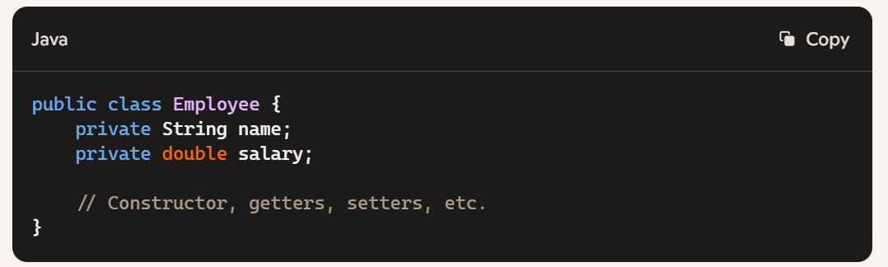

If you try to add Employee objects to a TreeSet without implementing Comparable or providing a Comparator:

Set<Employee> treeSet = new TreeSet<>();

treeSet.add(new Employee("John", 60000)); // This will throw a ClassCastException

**Solution 1: Implement Comparable**

Make the Employee class implement Comparable:

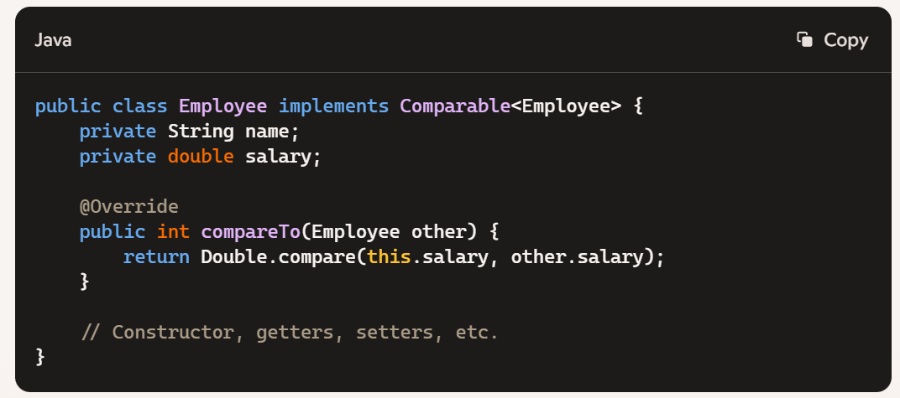

**Solution 2: Provide a Comparator**

Provide a Comparator when creating the TreeSet:

Set<Employee> treeSet = new TreeSet<>(Comparator.comparingDouble(Employee::getSalary));

treeSet.add(new Employee("John", 60000)); // Works fine

Without either of these, the TreeSet won't know how to order the Employee objects, leading to a runtime exception.

### Set<Employee> treeSet = new TreeSet<>(); treeSet.add(new Employee("John", 60000));

### This will throw a ClassCastException. Why is that?

This code throws a ClassCastException because TreeSet relies on the natural ordering of its elements or a provided comparator to sort the elements. If an Employee object does not implement the Comparable interface, the TreeSet does not know how to compare and order these objects.

**Solution:**

You need to make the Employee class implement the Comparable interface and override the compareTo method:

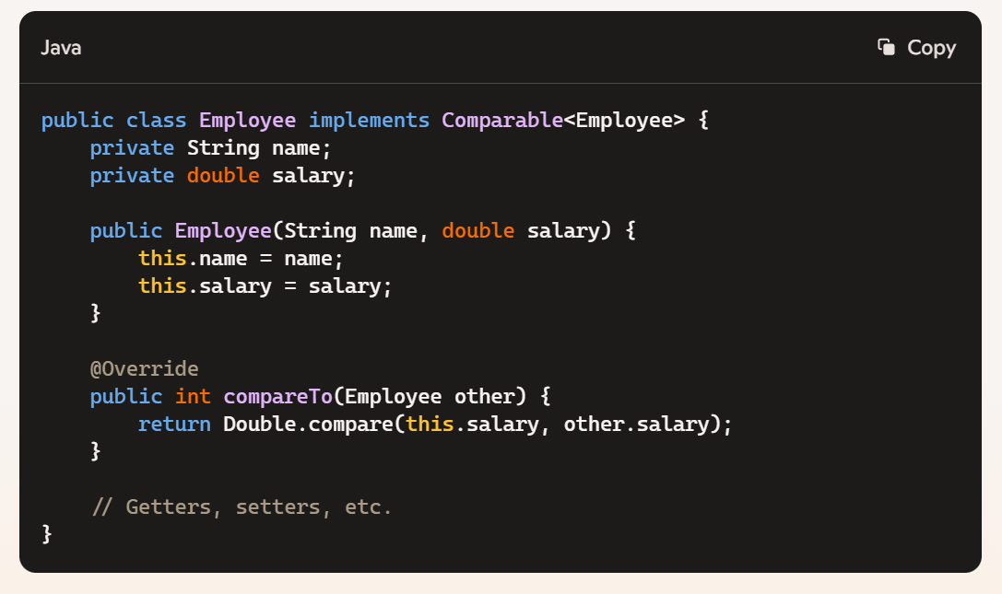

**Alternative:**

If you don't want to modify the Employee class, you can provide a Comparator when creating the TreeSet:

Set<Employee> treeSet = new TreeSet<>(Comparator.comparingDouble(Employee::getSalary));

treeSet.add(new Employee("John", 60000));

Both approaches will prevent the ClassCastException by ensuring that the TreeSet knows how to compare Employee objects.

When you add an Employee object to a TreeSet without implementing Comparable or providing a Comparator, the TreeSet tries to cast the elements to the Comparable interface internally, so it can call their compareTo method to determine the order.

**What’s Being Cast:**

* The TreeSet internally casts each element to Comparable when trying to sort them.
* Since Employee doesn’t implement Comparable in your original code, the cast fails, and a ClassCastException is thrown.

**Internal Process:**

When you add an Employee to the TreeSet, it performs a cast similar to this:

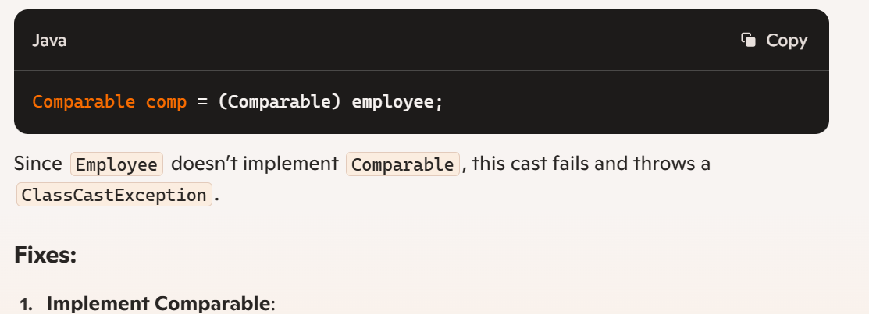

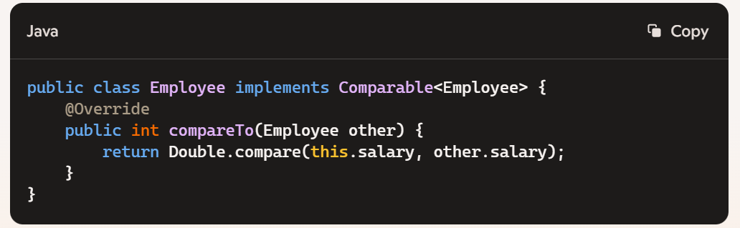 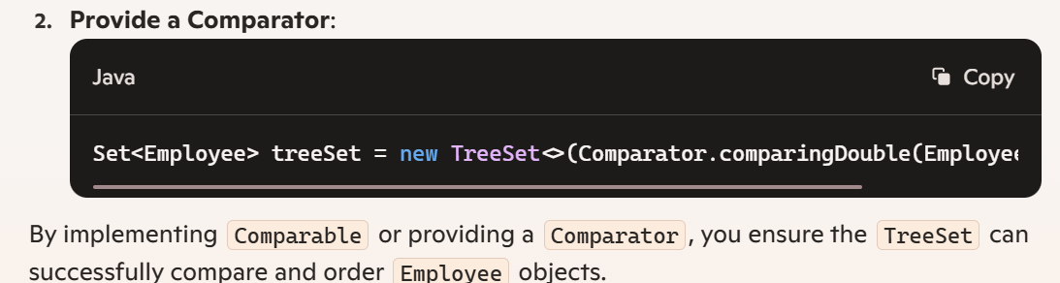 When you provide a Comparator, the Employee object doesn't need to be cast to Comparable.  Instead, the TreeSet directly uses the Comparator to compare the objects.

**How it Works:**

* **Without Comparator**: The TreeSet tries to cast objects to Comparable and calls the compareTo method.
* **With Comparator**: The TreeSet uses the provided Comparator to determine the order of elements. There's no need for casting to Comparable.

**Example**:

Set<Employee> treeSet = new TreeSet<>(Comparator.comparingDouble(Employee::getSalary));

treeSet.add(new Employee("John", 60000));

In this case, the Comparator you provided (Comparator.comparingDouble(Employee::getSalary)) is used to compare Employee objects. The TreeSet calls the compare method of the Comparator, avoiding the need to cast the Employee objects to Comparable.

So, the Comparator handles all comparisons, keeping things smooth and type-safe.

### What is the time complexity for basic operations (add, remove, contains) in a TreeSet?

The time complexity for basic operations in a TreeSet—like add, remove, and contains—is O(log n). This efficiency stems from the fact that TreeSet is backed by a Red-Black tree, a self-balancing binary search tree.

### What is a Red-Black Tree?

A **Red-Black Tree**is a self-balancing[binary search tree](https://www.geeksforgeeks.org/binary-search-tree-set-1-search-and-insertion) where each node has an additional attribute: a color, which can be either **red** or **black**. The primary objective of these trees is to maintain balance during insertions and deletions, ensuring efficient data retrieval and manipulation.

**Properties of Red-Black Trees**

A[Red-Black Tree](https://www.geeksforgeeks.org/introduction-to-red-black-tree) have the following properties:

1. **Node Color**: Each node is either red or **black**.
2. **Root Property**: The root of the tree is always **black**.
3. **Red Property**: Red nodes cannot have red children (no two consecutive red nodes on any path).
4. **Black Property**: Every path from a node to its descendant null nodes (leaves) has the same number of **black** nodes.
5. **Leaf Property**: All leaves (NIL nodes) are **black**.

These properties ensure that the longest path from the root to any leaf is no more than twice as long as the shortest path, maintaining the tree’s balance and efficient performance.

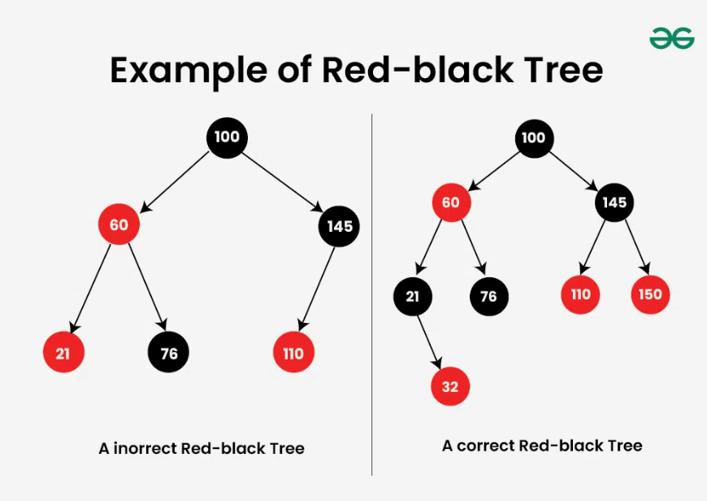

The **Correct Red-Black Tree** in above image ensures that every path from the root to a leaf node has the same number of black nodes. In this case,​ there is one (excluding the root node).

The**Incorrect Red Black Tree** does not follow the red-black properties as**two red nodes** are adjacent to each other. Another problem is that one of the paths to a leaf node has zero black nodes, whereas the other two contain a black node.

### Can you store null elements in a TreeSet? Why or why not?

You cannot store null elements in a TreeSet. This is because TreeSet relies on comparisons to maintain order, and attempting to compare null with other elements would throw a NullPointerException. Simply put, TreeSet and null elements just don’t mix well together!

To iterate through the elements of a TreeSet in reverse order, you can use the descendingIterator() method. This method returns an iterator that iterates over the elements in reverse order.

TreeSet<Integer> treeSet = new TreeSet<>();

treeSet.add(1);

treeSet.add(2);

treeSet.add(3);

Iterator<Integer> iterator = treeSet.descendingIterator();

while (iterator.hasNext()) {

System.out.println(iterator.next());

}

This code will print the elements in reverse order: 3, 2, 1.

### If I try to add Enum constants to a TreeSet, What sorting order will it use?

When you add Enum constants to a TreeSet, it will sort them based on the natural ordering of the Enum constants. This means they will be sorted in the order in which they were declared in the Enum class.

Natural ordering for Enums means they are sorted based on the order of their declaration in the Enum class. For example:

public enum Category {

FOOD,

UTENSILS,

CLEANING,

OFFICE

}

In this case, if you add these Enum constants to a TreeSet, they will be sorted as FOOD, UTENSILS, CLEANING, OFFICE. This is because TreeSet uses the compareTo method of Enum, which sorts according to their declaration order in the code.

Each Enum constant in Java has a natural ordering defined by the order of its declaration in the Enum type. This ordering is intrinsic to Enums and is established by their compareTo method.

Here’s the kicker: the compareTo method for Enums is implemented to return the ordinal value of the Enum constant. This ordinal value corresponds to the position of the constant in its Enum declaration. For example:

public enum Category {

FOOD, // Ordinal value 0

UTENSILS, // Ordinal value 1

CLEANING, // Ordinal value 2

OFFICE // Ordinal value 3

}

When you add these Enum constants to a TreeSet, TreeSet uses the compareTo method (which internally uses the ordinal value) to maintain order. Thus, it ensures the constants are sorted according to their declaration order in the Enum.

### What will be the output of this code?

Set mySet = new TreeSet();

mySet.add("4567");

mySet.add("5678");

mySet.add("6789");

for(String s: mySet){ System.out.println(s); }

In this case, the TreeSet is storing strings and will automatically sort them in their natural order, which is lexicographical (alphabetical) order for strings.

So, the strings "4567", "5678", and "6789" are already in lexicographical order. The TreeSet will keep them in that order.

The output will be

4567

5678

6789

### public class BuggyBread1{

public static void main (String args[]) {

Set<String> mySet = new TreeSet<String>();

mySet.add(""1"");

mySet.add(""2"");

mySet.add(""111"");

for(String d: mySet){

System.out.println(d);

}}}

1

111

2

TreeSet maintains the elements in the ascending order which is identified by the compareTo method. compareTo method in String has been defined such that it results in the natural alphabetic Order. Here the elements in the TreeSet are of String and not of Integer. In String Natural Order, 111 comes before 2 as ascii of 1st character first determines the order.

### HashSet

### Explain the internal implementation of a HashSet.

[https://app.pluralsight.com/ilx/video-courses/d9e230ee-4fd7-49df-9d9f-affa2431f05c/f8c9fd95-023b-498f-9e5c-e573bf50ba04/978c0699-49b0-46e5-bd28-b60be4f68e94](https://app.pluralsight.com/ilx/video-courses/d9e230ee-4fd7-49df-9d9f-affa2431f05c/f8c9fd95-023b-498f-9e5c-e573bf50ba04/978c0699-49b0-46e5-bd28-b60be4f68e94%20) The HashSet in Java is built on top of a HashMap, utilizing its features to ensure unique elements and fast access. Here’s a detailed look at its internal workings:

**Core Components**

1. **Backed by HashMap**: Internally, a HashSet uses an instance of HashMap to store its elements. The elements of the set are stored as keys in the HashMap, and the values are typically a constant object.

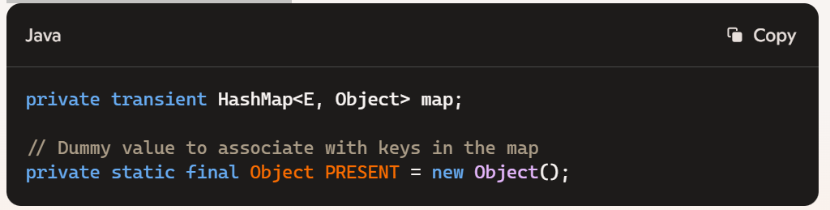

**Key Methods**

1. **Adding Elements**:
   * When you add an element using add(E e), the HashSet puts the element as a key in the backing HashMap.

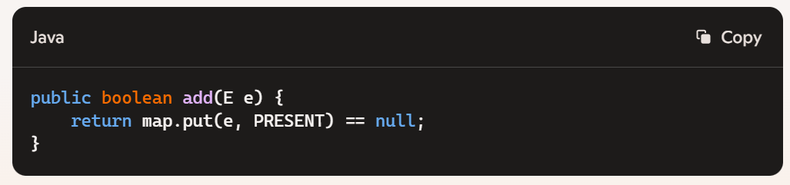

1. **Removing Elements**:

* Removing an element from a HashSet removes the corresponding key from the backing HashMap.

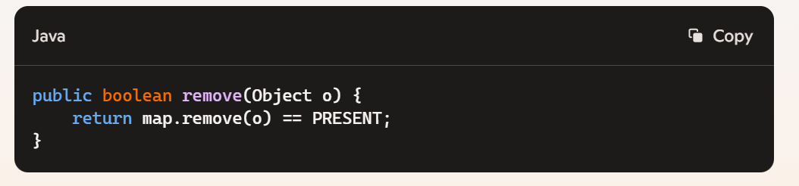

1. **Checking for Containment:**

* The contains method checks if the HashSet contains a particular element by checking the presence of the key in the HashMap.

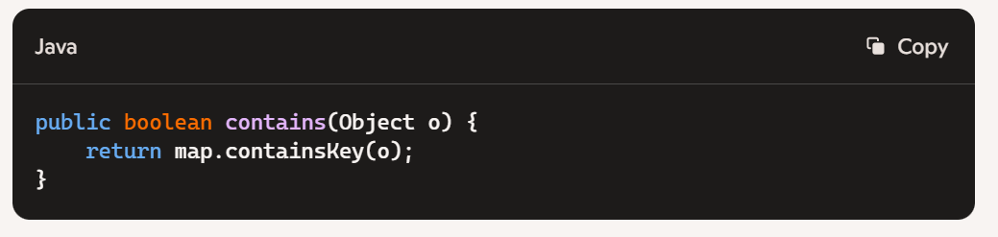

**Internal Mechanics**

* **Hashing**: Each element added to the HashSet is hashed using its hashCode method. This hash code determines the bucket in which the element will be placed within the HashMap.
* **Uniqueness**: The HashMap ensures that each key is unique, thus the HashSet automatically ensures that all its elements are unique.
* **Performance**: The HashSet benefits from the constant-time performance characteristics of HashMap for add, remove, and contains operations.

**Example Usage:**

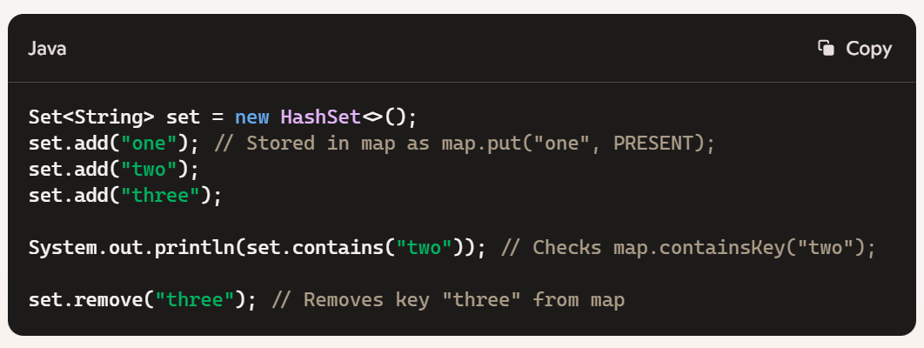

By leveraging HashMap internally, HashSet provides an efficient and straightforward way to store unique elements with quick access times.

**You**

26. Explain the internal implementation of a HashSet.

**Copilot**

So, a HashSet in Java is internally backed by a HashMap. When you add an element to the HashSet, it uses the element as a key in the HashMap, with a constant dummy value (like Boolean.TRUE).

Here's a rough outline of how it works:

* **Buckets and hash codes**: The HashMap uses an array of "buckets" to store elements. When you add an element, its hashCode is computed, and this determines which bucket the element goes into.
* **Collisions**: If two elements have the same hash code (a collision), they're stored in a linked list or tree within that bucket.
* **equals()**: The HashSet relies on the equals() method to check if two elements are the same. If an element with the same hashCode already exists in the bucket, equals() is used to ensure it's not a duplicate.
* **Rehashing**: When the number of elements exceeds the capacity threshold, the HashMap dynamically increases the number of buckets (rehashing) to maintain performance.

### Explain how to implement a HashSet in java with a user defined object.

Let’s dive into creating a HashSet in Java with a user-defined object. A HashSet is a collection that ensures uniqueness of its elements and doesn’t allow duplicates. When working with custom objects, we need to pay attention to equality and hash code considerations.

Here are the steps to implement a HashSet with a user-defined object:

1. **Define Your User-Defined Class**:
   * First, create a class that represents your user-defined object. Let’s call it Employee for our example.
   * The Employee class should override the equals() and hashCode() methods to ensure proper comparison and hashing.
2. **Implement equals() and hashCode()**:
   * The equals() method compares two objects for equality based on their content (attributes).
   * The hashCode() method returns an integer value that represents the object’s hash code.
   * These methods are crucial for HashSet to determine uniqueness and efficient storage.
3. **Create a HashSet of Employee Objects**:
   * Instantiate a HashSet to store your Employee objects.
   * Add instances of Employee to the set using the add() method.
4. **Example Implementation**:
5. import java.util.HashSet;
6. class Employee {
7. private int id;
8. private String name;
9. public Employee(int id, String name) {
10. this.id = id;
11. this.name = name;
12. }
13. @Override
14. public boolean equals(Object o) {
15. if (this == o) return true;
16. if (o == null || getClass() != o.getClass()) return false;
17. Employee employee = (Employee) o;
18. return id == employee.id;
19. }
20. @Override
21. public int hashCode() {
22. return id;
23. }
24. @Override
25. public String toString() {
26. return "Employee{" +
27. "id=" + id +
28. ", name='" + name + '\'' +
29. '}';
30. }
31. }
32. public class HashSetExample {
33. public static void main(String[] args) {
34. HashSet<Employee> employeeSet = new HashSet<>();
35. // Create some Employee objects
36. Employee emp1 = new Employee(101, "Alice");
37. Employee emp2 = new Employee(102, "Bob");
38. // Add employees to the set
39. employeeSet.add(emp1);
40. employeeSet.add(emp2);
41. // Print the set
42. for (Employee emp : employeeSet) {
43. System.out.println(emp);
44. }
45. }
46. }

**Notes**:

* + In the example above, we override equals() to compare employees based on their id.
  + The hashCode() method ensures proper hashing for efficient storage in the HashSet.

Remember, when creating a HashSet with custom objects, always handle equality and hash code correctly to maintain uniqueness and proper functioning.

### What happens if you try to add a User Defined object to a HashSet without overriding hashcode() and equals() methods?

When you add a user-defined object to a HashSet without overriding the hashCode () and equals() methods, the default implementations from the Object class are used. Here’s what you need to know:

**Default Behavior:**

* **hashCode()**: The default implementation of hashCode() in the Object class returns a distinct integer for each object, which is derived from the memory address of the object.
* **equals()**: The default implementation of equals() compares the memory addresses of the objects. So, two objects are considered equal only if they are the same instance.

**Consequences:**

1. **Ineffective Hashing**: Since the default hashCode() method returns different values for different instances, even if their contents are logically equal, the HashSet will treat them as different objects and store them in separate buckets.
2. **Duplicate Entries**: Without proper equals() and hashCode() implementations, logically equal objects will be treated as different, leading to duplicate entries in the HashSet.

**Example:**

class Employee {

private String name;

private double salary;

public Employee(String name, double salary) {

this.name = name;

this.salary = salary;

}

}

HashSet<Employee> set = new HashSet<>();

set.add(new Employee("John", 60000));

set.add(new Employee("John", 60000));

// Even though the objects are logically equal, the HashSet will treat them as different

System.out.println(set.size()); // Output: 2

**Solution:**

Override hashCode() and equals() to ensure proper functionality:

class Employee {

private String name;

private double salary;

public Employee(String name, double salary) {

this.name = name;

this.salary = salary;

}

@Override

public boolean equals(Object obj) {

if (this == obj) return true;

if (obj == null || getClass() != obj.getClass()) return false;

Employee employee = (Employee) obj;

return Double.compare(employee.salary, salary) == 0 &&

name.equals(employee.name);

}

@Override

public int hashCode() {

return Objects.hash(name, salary);

}

}

HashSet<Employee> set = new HashSet<>();

set.add(new Employee("John", 60000));

set.add(new Employee("John", 60000));

// Now, the HashSet will treat them as equal

System.out.println(set.size()); // Output: 1

So, without overriding hashCode() and equals(), a HashSet can't properly identify and handle logically equivalent objects.

### Tell me more about the Comparable and Comparator interfaces.

Let’s explore the world of sorting in Java and understand the roles of the Comparable and Comparator interfaces. These two interfaces are essential tools for implementing sorting functionalities in collections. They allow you to define custom sorting orders for objects based on specific criteria.

**Comparable Interface**

1. **What is Comparable?**
   * The Comparable interface is part of the java.lang package.
   * It enables an object to compare itself with other objects of the same type.
   * When a class implements Comparable, it defines a natural ordering for its instances.
2. **How Does It Work?**
   * The class that implements Comparable must override the compareTo() method.
   * The compareTo() method compares the current object with another object and returns:
     + A negative value if the current object is less than the other object.
     + Zero if they are equal.
     + A positive value if the current object is greater than the other object.
3. **Example: Sorting Movies by Year**
   * Suppose we have a Movie class with attributes like rating, name, and year.
   * By implementing Comparable<Movie>, we can sort a list of movies based on their release year.
   * Example code snippet:
   * class Movie implements Comparable<Movie> {
   * // Other attributes and methods...
   * public int compareTo(Movie other) {
   * return this.year - other.year;
   * }
   * }

**Comparator Interface**

1. **What is Comparator?**
   * The Comparator interface is part of the java.util package.
   * Unlike Comparable, it is external to the element type being compared.
   * It allows you to create multiple custom sorting sequences for the same class.
2. **How Does It Work?**
   * You create a separate class (or use a lambda expression) that implements Comparator.
   * The compare() method in the Comparator class defines the custom sorting logic.
   * You can compare objects based on different criteria (e.g., rating, name, age).
   * The compare() method in Java compares two class specific objects (x, y) given as parameters. It returns the value:

**0:** if (x==y)

**-1:** if (x < y)

**1:** if (x > y)

**Syntax:**

public int compare(Object obj1, Object obj2)

1. **Example: Sorting Movies by Rating**
   * Suppose we want to sort movies by their rating.
   * We create a RatingComparator class that implements Comparator<Movie>.
   * Example code snippet:
   * class RatingComparator implements Comparator<Movie> {
   * public int compare(Movie m1, Movie m2) {
   * return Double.compare(m2.getRating(), m1.getRating());
   * }
   * }
2. **Using Comparator with Collections**
   * To sort a collection using a Comparator, use the overloaded sort() method from the Collections class.
   * Example:
   * List<Movie> movies = new ArrayList<>();
   * // Add movies to the list...
   * Collections.sort(movies, new RatingComparator());

In summary, Comparable defines the natural ordering within the class itself, while Comparator allows you to create custom sorting orders externally. Choose the right tool based on your specific sorting requirements! 🌟

### In Core Java, when adding an object to set, why shoud we implement both the equals and hashcode method? Why not just the equals method?

<https://app.pluralsight.com/ilx/video-courses/d9e230ee-4fd7-49df-9d9f-affa2431f05c/f8c9fd95-023b-498f-9e5c-e573bf50ba04/978c0699-49b0-46e5-bd28-b60be4f68e94>

**HashSet Basics**

* When you add an object to a Set (specifically HashSet), the hashCode method determines which bucket the object belongs to within the hash table.
* If multiple objects have the same hashCode (collision), then the equals method determines whether those objects are actually equal.

**Why Both Methods?**

* **hashCode**: This method gives a bucket location. If two objects have the same hashCode, the Set will then use equals to see if the objects are truly identical.
* **equals**: Determines logical equality. If you override this without also overriding hashCode, you break the contract which can lead to inconsistent behavior.

**The Contract:**

* **Consistency**: If equals determines two objects are equal, they **must** return the same hashCode.
* **Not Necessarily Vice Versa**: If two objects have the same hashCode, they are not necessarily equal as per equals.

**Example:**

Consider these two methods in a Person class:

@Override

public boolean equals(Object obj) {

if (this == obj) return true;

if (obj == null || getClass() != obj.getClass()) return false;

Person person = (Person) obj;

return age == person.age && name.equals(person.name);

}

@Override

public int hashCode() {

return Objects.hash(name, age);

}

Without both, the Set can end up with duplicate objects or fail to locate objects accurately.

So, ensuring both equals and hashCode are properly overridden is like making sure you've got a lock and key that fit together perfectly.

### Iteration on a hashset means calling next()?

When you're iterating over a HashSet, you're using an Iterator and calling the next() method to move through the elements. The Iterator provides a way to traverse the collection without exposing its underlying implementation.

Example:

HashSet<String> set = new HashSet<>();

set.add("one");

set.add("two");

set.add("three");

Iterator<String> iterator = set.iterator();

while (iterator.hasNext()) {

String element = iterator.next();

System.out.println(element);

}

In this example, the next() method is called repeatedly to get the next element in the HashSet until all elements have been visited. Remember, the order of iteration is not guaranteed in a HashSet since it doesn't maintain any order of its elements.

### Should'nt iteration performance then be O(Capacity/N) where N is the number of elements?

While the Capacity/N term might seem relevant, iteration performance is typically just considered O(N) because it needs to visit each element exactly once.

Here's why:

* **Iteration Cost**: The next() method in an iterator visits each slot in the internal array, but only steps over slots that contain actual elements.
* **Performance in Practice**: Even if there are gaps (empty slots) due to the underlying array's capacity, the next() method skips those, and the primary factor remains the number of elements (N).

In essence, the actual time spent iterating is proportional to the number of elements present, not the total capacity.

### Compare the performance of a HashSet vs. TreeSet.

[https://app.pluralsight.com/ilx/video-courses/d9e230ee-4fd7-49df-9d9f-affa2431f05c/f8c9fd95-023b-498f-9e5c-e573bf50ba04/978c0699-49b0-46e5-bd28-b60be4f68e94](https://app.pluralsight.com/ilx/video-courses/d9e230ee-4fd7-49df-9d9f-affa2431f05c/f8c9fd95-023b-498f-9e5c-e573bf50ba04/978c0699-49b0-46e5-bd28-b60be4f68e94%20)

Comparing HashSet and TreeSet comes down to understanding their internal structures and the operations you’re performing most frequently. Here’s the lowdown:

**HashSet**

* **Internal Structure**: Backed by a HashMap.
* **Performance**:
  + **Add, Remove, Contains**: O(1) on average, since these operations depend on the hash code of the elements.
  + **Iteration**: O(n) where n is the number of elements.
* **Order**: Does not maintain any order of the elements.
* **When to Use**: Ideal for scenarios where quick add, remove, and contains operations are needed and order doesn’t matter.

**TreeSet**

* **Internal Structure**: Backed by a Red-Black Tree.
* **Performance**:
  + **Add, Remove, Contains**: O(log n), due to the need to maintain the tree's balanced structure.
  + **Iteration**: O(n) where n is the number of elements, but elements are returned in sorted order.
* **Order**: Maintains elements in natural order or by a specified comparator.
* **When to Use**: Best suited for scenarios where sorted order is important or when you need navigational operations like finding the closest greater or smaller element.

**Summary**

* **HashSet**: Faster for add, remove, and contains operations. Best when you don't need order.
* **TreeSet**: Slower for add, remove, and contains due to maintaining order, but provides sorted elements and navigational methods.

Choosing between the two depends on your specific needs: speed and no order with HashSet, or sorted order and navigational operations with TreeSet.

### When would you use an HashSet vis-a-vis LinkedHashSet?

<https://app.pluralsight.com/ilx/video-courses/d9e230ee-4fd7-49df-9d9f-affa2431f05c/f8c9fd95-023b-498f-9e5c-e573bf50ba04/01d9886f-0506-4c14-8ac6-a4807825cb67>

**HashSet:**

* **When to Use**:
  + You need to maintain a collection of unique elements.
  + Order of elements doesn’t matter.
  + Fast performance for add, remove, and contains operations.
* **Performance**:
  + O(1) average time complexity for add, remove, and contains operations.
  + Backed by a hash table, providing constant-time performance on average.
* **Characteristics**:
  + Doesn’t maintain any order of elements.
  + Ideal for scenarios where order isn’t important and you need fast access.

**LinkedHashSet:**

* **When to Use**:
  + You need to maintain a collection of unique elements with predictable iteration order.
  + Order of insertion matters.
  + Performance close to HashSet but with the additional overhead of maintaining order.
* **Performance**:
  + O(1) average time complexity for add, remove, and contains operations.
  + Slightly slower than HashSet due to the overhead of maintaining a doubly linked list for order.
* **Characteristics**:
  + Maintains insertion order of elements.
  + Suitable for scenarios where you need fast access but also need to keep elements in a specific order.

**Example Use Cases:**

* **HashSet**:
  + Storing a set of unique user IDs where the order of IDs doesn’t matter.
* **LinkedHashSet**:
  + Storing recent user actions where you need to maintain the order of actions as they occurred.

The choice depends on your specific requirements—whether order matters and how critical performance is.

# Maps

### HashMap

### Explain the internal implementation of a HashMap.

**Internal Implementation of HashMap**

* **Buckets**: A HashMap internally uses an array of Node objects, known as buckets, to store key-value pairs. Each bucket corresponds to a hash value of the key.
* **Hash Function**: When a key is added, the hashCode of the key is computed. This hash code is then transformed into an index for the bucket array.
* **Linked List**: If multiple keys map to the same bucket (hash collision), the entries in that bucket are stored in a linked list. Starting with Java 8, when the number of entries in a bucket exceeds a certain threshold (typically 8), the linked list is transformed into a balanced tree for better performance.

**Core Components:**

* **Node Class**: Each entry in the map is represented by a Node object, which contains the key, value, hash, and a reference to the next node.

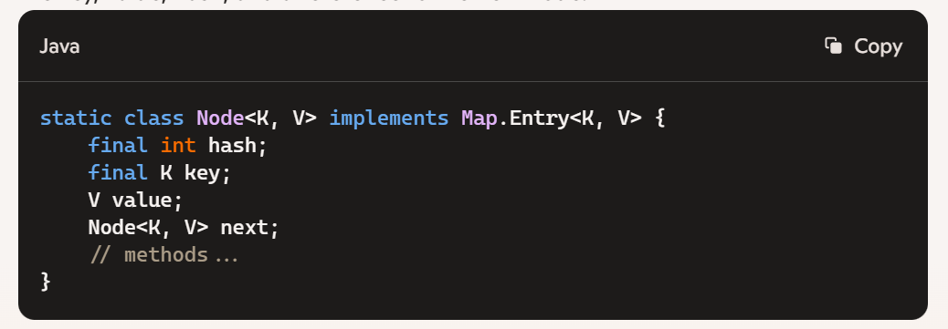

**Key Methods:**

1. **put(K key, V value)**:
   * Computes the hash of the key.
   * Determines the bucket location.
   * If the bucket is empty, the new entry is added directly.
   * If not, it traverses the linked list or tree to find the correct position, updating the value if the key already exists or appending the new node otherwise.
2. **get(Object key)**:
   * Computes the hash of the key.
   * Determines the bucket location.
   * Traverses the linked list or tree in that bucket to find the matching key and returns the associated value.

**Example:**

Map<String, Integer> map = new HashMap<>();

map.put("one", 1); // hash("one") determines the bucket

map.put("two", 2); // hash("two") determines another bucket or same bucket if hash collision occurs

Integer value = map.get("one"); // hash("one") determines bucket, retrieves value

This structure balances performance and efficiency, making HashMap a powerful and versatile data structure.

When HashMap traverses the linked list (or tree) to find the correct position, it uses the equals method to compare keys. This ensures that it accurately identifies whether the key already exists in the map.

Here’s how it works:

1. **Hash Code Check**: First, the hashCode of the key is computed and used to locate the appropriate bucket.
2. **Equals Method**: If there are multiple entries in that bucket (due to hash collisions), the HashMap will iterate through the linked list or tree and use the equals method to check if any of the keys in the entries match the key being added or queried.

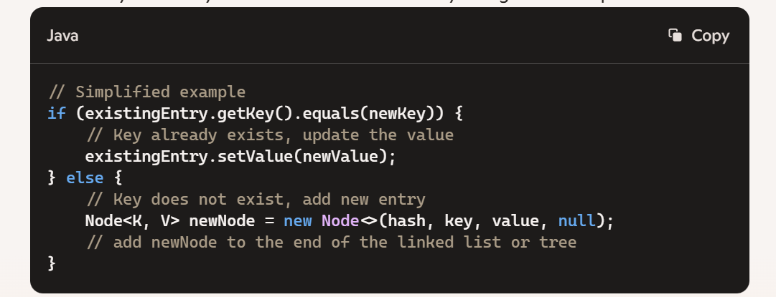

This combination of hashCode and equals ensures that HashMap operations are efficient and accurate. If only hashCode were used, there could be collisions; if only equals were used, every comparison would take longer. Together, they make HashMap work like a charm.

### What is a ConcurrentHashMap?

A ConcurrentHashMap is a thread-safe variant of HashMap introduced in Java's java.util.concurrent package. It's designed for use in concurrent applications where multiple threads might be reading from and writing to the map simultaneously.

**Key Features:**

1. **Thread Safety**: Ensures that multiple threads can safely interact with the map without causing data inconsistencies or corruptions.
2. **Lock Stripes**: Instead of locking the entire map, ConcurrentHashMap uses a concept called lock striping, which divides the map into segments, and only locks a particular segment during updates. This significantly reduces contention and improves performance.
3. **Non-blocking Reads**: Reads are non-blocking, meaning they do not require locking and can be done concurrently with writes.
4. **Scalability**: Its design allows for higher throughput and scalability compared to synchronized collections like Hashtable or Collections.synchronizedMap.

**Example Usage:**

import java.util.concurrent.ConcurrentHashMap;

public class ConcurrentHashMapExample {

public static void main(String[] args) {

ConcurrentHashMap<String, Integer> map = new ConcurrentHashMap<>();

// Adding elements

map.put("one", 1);

map.put("two", 2);

// Reading elements

System.out.println(map.get("one"));

// Removing elements

map.remove("two");

// Concurrent operations can be safely executed

}

}

**When to Use:**

* **High Concurrency**: When multiple threads need to read from and write to a map simultaneously.
* **Performance-Sensitive Applications**: When minimizing contention and maximizing throughput is crucial.

It's a rock-solid choice for scenarios where you need the performance of a non-blocking map and the safety of synchronized access.

### Explain the internal implementation of a TreeMap.

A TreeMap in Java is a Red-Black Tree-based implementation of the NavigableMap interface. It ensures that the keys are stored in sorted order, maintaining a balanced binary search tree to provide efficient operations. Here's a detailed look at its internal workings:

**Core Components**

1. **Red-Black Tree**: Internally, TreeMap uses a Red-Black Tree, which is a self-balancing binary search tree. This ensures that the tree remains balanced after insertions and deletions, providing efficient O(log n) time complexity for the basic operations (add, remove, get).
2. **Entry Class: Each node in the Red-**Black Tree is represented by an Entry object, which holds the key-value pair, references to left and right child nodes, and the color of the node (red or black).

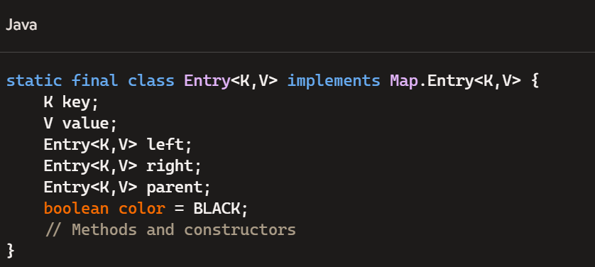

**Key Methods**

1. **Adding Elements**:
   * Inserting a new key-value pair involves standard binary search tree insertion followed by rebalancing to maintain the Red-Black Tree properties.
   * The tree is rebalanced using rotations and color flips.
2. **Removing Elements:**

* Deleting an entry requires rebalancing the tree to maintain Red-Black Tree properties.
* The tree is rebalanced using rotations and color flips, similar to insertion

1. **Accessing Elements:**

* The get method uses binary search to find the node containing the specified key.

**Key Properties:**

* **Balanced Tree**: The Red-Black Tree ensures balanced trees, maintaining efficient O(log n) operations.
* **Sorted Order**: Maintains keys in sorted order.
* **NavigableMap**: Provides additional methods to navigate through the map, like ceilingEntry, floorEntry, higherKey, and lowerKey.

The TreeMap’s implementation of a Red-Black Tree provides a reliable and efficient way to store and retrieve key-value pairs in a sorted manner.

A Red-Black Tree is a type of self-balancing binary search tree. It maintains balance through specific properties that ensure the tree remains balanced during insertions and deletions, providing efficient operations. Here’s a breakdown of its core features and properties:

**Core Properties**

1. **Node Color**: Each node is either red or black.
2. **Root and Leaves**: The root is always black, and all leaves (null nodes) are black.
3. **Red Rule**: Red nodes cannot have red children (no two red nodes can be adjacent).
4. **Black Rule**: Every path from a node to its descendant leaves must have the same number of black nodes.

**Operations**

* **Insertion and Deletion**: When nodes are inserted or deleted, the tree may temporarily violate its properties. Rebalancing is achieved through color changes and rotations (left or right).
* **Balancing**: The tree is kept roughly balanced through these operations, ensuring O(log n) time complexity for search, insert, and delete operations.

**Example**

Here’s a visual example of a Red-Black Tree:

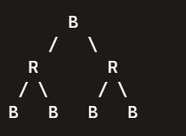

* The root is black.
* Red nodes (R) do not have red children.
* Every path from the root to the leaves has the same number of black nodes.

**Applications**

* **Databases**: Often used in database indexing.
* **Memory Management**: Employed in memory allocators for efficient searching.

Red-Black Trees balance themselves through simple yet effective rules, making them robust for various computing tasks.

### NavigableMap is an interface?

NavigableMap is indeed an interface in Java, part of the java.util package. It extends the SortedMap interface to provide navigation methods to navigate through the map in a sorted order.

**Key Features**

* **Navigable Methods**: Provides methods to navigate through the map, like ceilingEntry, floorEntry, higherKey, and lowerKey.
* **Sub-Map Views**: Allows you to obtain sub-map views of portions of the map.
* **Descending Views**: Supports descending views to navigate in reverse order.

**Example**

Let's say you have a TreeMap, which implements the NavigableMap interface:

NavigableMap<String, Integer> navigableMap = new TreeMap<>();

navigableMap.put("one", 1);

navigableMap.put("two", 2);

navigableMap.put("three", 3);

// Navigable methods

System.out.println(navigableMap.ceilingKey("one")); // Output: one

System.out.println(navigableMap.floorKey("two")); // Output: two

System.out.println(navigableMap.higherKey("one")); // Output: three

System.out.println(navigableMap.lowerKey("three")); // Output: two

// Sub-map views

NavigableMap<String, Integer> subMap = navigableMap.subMap("one", true, "three", true);

System.out.println(subMap); // Output: {one=1, two=2, three=3}

The NavigableMap interface brings a lot of versatility, making it easier to work with sorted maps in various ways.

### What is the difference between fail-safe and fail-fast?

Fail-safe and fail-fast are terms that describe how iterators behave when working with collections in concurrent environments.

**Fail-Fast:**

* **Definition**: Fail-fast iterators immediately throw a ConcurrentModificationException if they detect structural modification in the collection after the iterator was created.
* **Behavior**: They quickly fail to avoid unpredictable behavior by detecting that the underlying collection has changed.
* **Examples**: Iterators of ArrayList, HashMap, etc.

**Example**:

List<String> list = new ArrayList<>(Arrays.asList("one", "two", "three"));

Iterator<String> iterator = list.iterator();

while (iterator.hasNext()) {

System.out.println(iterator.next());

list.add("four"); // This will cause a ConcurrentModificationException

}

**Fail-Safe:**

* **Definition**: Fail-safe iterators operate on a clone of the collection, allowing modifications to the collection without throwing exceptions.
* **Behavior**: They don't throw exceptions when the collection is modified during iteration because they operate on a separate copy of the data.
* **Examples**: Iterators of CopyOnWriteArrayList, ConcurrentHashMap, etc.

**Example**:

CopyOnWriteArrayList<String> list = new CopyOnWriteArrayList<>(Arrays.asList("one", "two", "three"));

Iterator<String> iterator = list.iterator();

while (iterator.hasNext()) {

System.out.println(iterator.next());

list.add("four"); // This won't cause any issue

}

**Key Differences:**

* **Detection**: Fail-fast detects concurrent modifications and throws an exception immediately. Fail-safe doesn't detect changes and operates on a separate copy.
* **Usage**: Fail-fast is used in non-concurrent collections. Fail-safe is used in concurrent collections to ensure thread safety.

### Is the same reasoning applicable to HashMap vs. LinkedHashMap?

The comparison between HashMap and LinkedHashMap involves slightly different considerations, but the essence of performance and usage scenarios applies here as well.

**HashMap**

* **Order**: HashMap does not maintain any order of its elements. The order can change over time as elements are added or removed.
* **Performance**: Provides constant-time performance for the basic operations (add, remove, get) assuming a good hash function.
* **Usage**: Ideal for scenarios where order does not matter and you need fast access to key-value pairs.

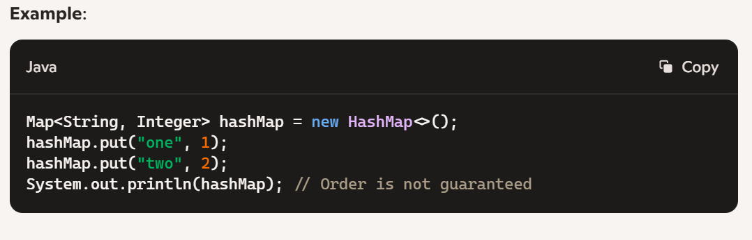

**LinkedHashMap**

* **Order**: Maintains a doubly-linked list running through all its entries. This means it maintains insertion order or access order (if configured).
* **Performance**: Slightly slower than HashMap due to the overhead of maintaining the linked list, but still provides constant-time performance for basic operations.
* **Usage**: Ideal for scenarios where you need to maintain the order of elements, such as caching with LRU (Least Recently Used) eviction policy.

**Example**:

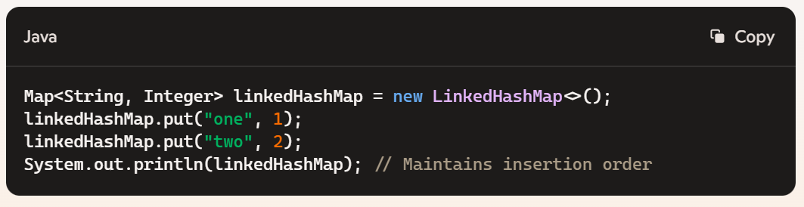 **Key Differences:**

* **Order**: HashMap doesn't care about order, LinkedHashMap does.
* **Performance**: HashMap is a touch faster due to no overhead of maintaining order, while LinkedHashMap trades a tiny bit of speed to keep order.

**When to Use Each:**

* **HashMap**: Use when you need quick access to elements and the order doesn't matter.
* **LinkedHashMap**: Use when you need to maintain the order of elements, either for consistent iteration order or to implement access-order caches.

# Exception Handling

### Explain the difference between checked and unchecked exceptions. Provide examples of each.

* + Discuss how checked exceptions must be declared in a method's throws clause and caught, while unchecked exceptions (runtime exceptions) do not need to be explicitly handled.

### How does the finally block work in a try-catch-finally statement? What happens if there’s a return statement in both the try and finally blocks?

* + Dive into the mechanics of the finally block and how it guarantees execution. Explore scenarios where both try and finally have return statements, emphasizing which value is ultimately returned.

The finally block in a try-catch-finally statement is a handy safety net, ensuring that the code within it gets executed regardless of whether an exception is thrown or caught. This is crucial for releasing resources like file handles, closing connections, or performing cleanup actions.

**How the finally Block Works:**

1. **Guaranteed Execution**: The finally block always runs, whether an exception is thrown or not. This guarantees that critical cleanup code runs without fail.

try {

// Code that might throw an exception

} catch (Exception e) {

// Handling exception

} finally {

// Cleanup code, always executed

}

**Return Statement in Both try and finally:**

This is where it gets interesting. If both try and finally blocks contain return statements, the return statement in the finally block will override the one in the try block.

**Example:**

public class FinallyDemo {

public static void main(String[] args) {

System.out.println(testMethod());

}

public static int testMethod() {

try {

return 1;

} finally {

return 2;

}

}

}

**Explanation:**

* **Execution Flow**: When the try block’s return statement is encountered, the value 1 is prepared to be returned.
* **Finally Executes**: Before the method can actually return 1, the finally block executes.
* **Overriding Return**: The return statement in the finally block overrides the return from the try block, so 2 is returned instead.

**Key Takeaways:**

* **Consistency**: Always ensure that finally blocks are used for cleanup actions rather than critical logic that impacts the method’s return value.
* **Clarity**: Keep your try-catch-finally blocks clear and predictable to avoid confusing behavior and maintain readability.

### **What is the purpose of custom exceptions? How do you create and use one in Java?**

* + Explain why custom exceptions are useful for application-specific error handling. Walk through the steps to create a custom exception by extending Exception or RuntimeException.

Custom exceptions are like personalized traffic signals for your code, making error handling much clearer and specific to the application's needs. By creating your own exception types, you can handle various error scenarios in a more granular and meaningful way.

**Why Custom Exceptions?**

1. **Readability and Maintainability**: Custom exceptions make it clear what the problem is, which leads to more readable and maintainable code.
2. **Specific Error Handling**: They allow you to differentiate between different types of errors and handle them appropriately.
3. **Encapsulation**: You can encapsulate error information that is specific to your application, making debugging easier.

**Creating a Custom Exception**

You can create a custom exception by extending either Exception (for checked exceptions) or RuntimeException (for unchecked exceptions).

**1. Extending**Exception

Here’s how you create a custom checked exception:

public class CustomCheckedException extends Exception {

public CustomCheckedException(String message) {

super(message);

}

public CustomCheckedException(String message, Throwable cause) {

super(message, cause);

}

}

**2. Extending**RuntimeException

Here’s how you create a custom unchecked exception:

public class CustomUncheckedException extends RuntimeException {

public CustomUncheckedException(String message) {

super(message);

}

public CustomUncheckedException(String message, Throwable cause) {

super(message, cause);

}

}

**Using Custom Exceptions**

You can throw these exceptions in your methods and handle them as needed:

**Throwing the Exception:**

public void someMethod() throws CustomCheckedException {

if (someCondition) {

throw new CustomCheckedException("Something went wrong!");

}

}

**Catching the Exception:**

public void anotherMethod() {

try {

someMethod();

} catch (CustomCheckedException e) {

System.out.println("Caught custom exception: " + e.getMessage());

}

}

Custom exceptions help you express the problem more clearly and handle specific situations differently.

### Describe exception chaining. How do you implement it in Java?

* + Discuss how exception chaining allows one exception to carry information about another exception. Provide code examples to show how to use the Throwable.initCause() method or constructor chaining.

Exception chaining in Java is a powerful mechanism that lets one exception carry the information of another, often indicating an underlying cause. This makes it easier to track the root problem through a stack of exceptions, enhancing debugging and error handling.

**How It Works:**

When an exception occurs, you might want to throw a new exception that better describes the current context but still keep a reference to the original exception. This is achieved by “chaining” the exceptions together.

**Using Throwable.initCause():**

You can use the initCause() method to set the cause of an exception after it has been created. Here's an example:

public class ExceptionChainingExample {

public static void main(String[] args) {

try {

methodA();

} catch (CustomException e) {

System.out.println("Caught exception: " + e);

System.out.println("Original cause: " + e.getCause());

}

}

public static void methodA() throws CustomException {

try {

methodB();

} catch (Exception e) {

CustomException customException = new CustomException("Exception in methodA");

customException.initCause(e); // Chaining the original exception

throw customException;

}

}

public static void methodB() throws Exception {

throw new Exception("Original cause in methodB");

}

}

**Constructor Chaining:**

Alternatively, you can use constructor chaining to pass the original exception as a parameter to the new exception's constructor.

public class ExceptionChainingExample {

public static void main(String[] args) {

try {

methodA();

} catch (CustomException e) {

System.out.println("Caught exception: " + e);

System.out.println("Original cause: " + e.getCause());

}

}

public static void methodA() throws CustomException {

try {

methodB();

} catch (Exception e) {

throw new CustomException("Exception in methodA", e); // Chaining the original exception

}

}

public static void methodB() throws Exception {

throw new Exception("Original cause in methodB");

}

}

class CustomException extends Exception {

public CustomException(String message) {

super(message);

}

public CustomException(String message, Throwable cause) {

super(message, cause);

}

}

**Key Points:**

* **Traceability**: Keeps the stack trace intact for better debugging.
* **Readability**: Enhances the clarity of exception handling by maintaining context.
* **Flexibility**: You can chain exceptions dynamically using initCause() or statically using constructors.

This ensures that you never lose sight of the original issue while adding layers of context-specific information to the exception stack. Makes handling complex errors a breeze!

# Layered Application

### What is a Layered application in software?

Let’s explore the concept of **layered architecture** in software development. Layered architecture, also known as tiered architecture, is a widely used design pattern that helps organize and structure software applications. It promotes modularity, separation of concerns, and scalability. Here’s what you need to know:

1. **What Is Layered Architecture?**
   * **Layered architecture** divides an application into a set of logical layers, each responsible for specific tasks.
   * These layers are stacked on top of each other, forming a hierarchy. Each layer interacts with adjacent layers in a well-defined manner.
   * The primary goal is to separate different concerns and responsibilities, making the application more maintainable and extensible.
2. **Common Layers in Layered Architecture:** While the exact number of layers can vary, most layered architectures consist of the following standard layers:
   * **1. Presentation Layer (UI Layer):**
     + This is the topmost layer—the part of the application that users directly interact with.
     + It handles user input, displays information, and manages the overall look and feel of the application.
     + Components in this layer include web pages, user interfaces, and views.
   * **2. Business Logic Layer (Service Layer):**
     + The business logic layer contains the core functionality of the application.
     + It implements business rules, processes data, and orchestrates interactions between different components.
     + Components in this layer include service classes, business logic, and workflow management.
   * **3. Data Access Layer (Persistence Layer):**
     + This layer deals with data storage and retrieval.
     + It interacts with databases, external APIs, or other data sources.
     + Components in this layer include data access objects (DAOs), repositories, and database connectors.
   * **4. Infrastructure Layer (Optional):**
     + Some layered architectures include an infrastructure layer.
     + It handles cross-cutting concerns such as logging, security, and caching.
     + Components in this layer include aspects, interceptors, and utility classes.
3. **Benefits of Layered Architecture:**
   * **Modularity**: Each layer has a specific purpose, making it easier to manage and maintain.
   * **Separation of Concerns**: Layers isolate different aspects of the application, reducing complexity.
   * **Scalability**: You can scale individual layers independently (e.g., adding more servers for the data access layer).
   * **Reusability**: Well-defined layers encourage reusable components.
4. **When to Use Layered Architecture:**
   * Layered architecture is suitable for most applications, especially those with clear separation between presentation, business logic, and data access.
   * It’s commonly used in web applications, enterprise systems, and client-server applications.

In summary, layered architecture provides a structured way to organize your software, making it easier to develop, maintain, and enhance.

### Explain the main layers in a typical layered application architecture. What responsibilities does each layer have?

A typical layered application architecture breaks down into several distinct layers, each with specific responsibilities to keep the application modular and maintainable. Here’s a quick overview:

**1. Presentation Layer:**

* **Purpose**: Manages the user interface and handles user interactions.
* **Responsibilities**:
  + Displaying data to the user.
  + Capturing user input.
  + Forwarding user actions to the appropriate layer for processing.
* **Examples**: Web pages, desktop GUIs, mobile app interfaces.

**2. Business Logic Layer (Service Layer):**

* **Purpose**: Implements the core business logic of the application.
* **Responsibilities**:
  + Processing input from the presentation layer.
  + Performing business rules and calculations.
  + Coordinating interactions between the presentation and data access layers.
* **Examples**: Service classes, business rules engines.

**3. Data Access Layer (Persistence Layer):**

* **Purpose**: Manages data interactions and storage.
* **Responsibilities**:
  + CRUD operations (Create, Read, Update, Delete).
  + Communicating with databases and other storage systems.
* **Examples**: Repository classes, DAOs (Data Access Objects).

**4. Database Layer:**

* **Purpose**: Provides persistent storage for data.
* **Responsibilities**:
  + Storing data in a structured format.
  + Ensuring data integrity and consistency.
  + Handling data queries and transactions.
* **Examples**: SQL databases, NoSQL databases.

Each layer interacts with the layer directly above or below it, adhering to principles of separation of concerns. This modular approach makes applications easier to develop, test, maintain, and scale.

### What are the advantages of using a layered architecture? Can you describe some potential drawbacks?

* Discuss benefits like separation of concerns, maintainability, and testability, along with challenges like complexity and performance overhead.

**Advantages:**

1. **Separation of Concerns**:
   * Each layer handles a specific aspect of the application, which makes the system easier to understand and manage.
2. **Maintainability**:
   * Changes in one layer, like updating the user interface, can often be made without affecting other layers, like the data access layer.
3. **Reusability**:
   * Components or layers can be reused across different parts of the application or in other projects.
4. **Testability**:
   * Isolation of layers simplifies unit testing. You can test each layer independently, ensuring that specific functionalities work correctly.
5. **Scalability**:
   * Each layer can be scaled independently based on the needs. For example, you can scale out the database layer separately from the presentation layer.
6. **Flexibility**:
   * It allows for more flexibility in choosing technologies for each layer. For instance, you could use a web framework for the presentation layer and a different technology for the data layer.

**Potential Drawbacks:**

1. **Complexity**:
   * Introduces complexity in terms of layer management and communication, especially as the number of layers increases.
2. **Performance Overhead**:
   * Each layer adds overhead due to the additional abstraction, which can impact the application’s performance.
3. **Communication Overhead**:
   * Inter-layer communication can become complex and potentially slow down processes, particularly if the layers are deployed across different servers.
4. **Development Overhead**:
   * More layers mean more code and potentially more integration points to manage, which can increase development time and costs.

Layered architecture provides a robust framework for organizing your application, but like any architectural choice, it's important to weigh the benefits against the drawbacks based on your specific project requirements.

### Can you explain the role of DTOs (Data Transfer Objects) in a layered architecture? How do they differ from entities?

* Discuss how DTOs are used to transfer data between layers and the importance of keeping entities isolated from the presentation layer.

**DTOs (Data Transfer Objects)** play a vital role in layered architecture, primarily for transferring data between different layers of the application. Here's a deep dive into their role and how they differ from entities:

**Role of DTOs:**

1. **Data Transfer**:
   * DTOs are used to transfer data across different layers (e.g., from the service layer to the presentation layer, or between the controller and service layers).
   * They help reduce the number of method calls by aggregating data in a single object.
2. **Decoupling**:
   * DTOs help decouple different layers of the application. This separation ensures that changes in the data access layer do not directly affect the presentation layer and vice versa.
3. **Data Shaping**:
   * DTOs allow shaping and formatting data as needed for the consuming layer. You can control exactly what data is exposed to the client.
4. **Security**:
   * By using DTOs, sensitive data can be excluded from transfer objects, ensuring that only the necessary information is passed between layers.
5. **Validation**:
   * DTOs can include validation rules to ensure data integrity before it's sent across layers.

**Difference between DTOs and Entities:**

1. **Purpose**:
   * **DTOs**: Primarily used to transfer data between different parts of an application. They are usually plain objects without any business logic.
   * **Entities**: Represent the domain model and are typically used to map to database tables. Entities include both data and behavior (business logic).
2. **Scope**:
   * **DTOs**: Have a limited scope and are used temporarily during data transfer.
   * **Entities**: Have a wider scope and persist throughout the application lifecycle, typically managed by an ORM (Object-Relational Mapping) framework.
3. **Structure**:
   * **DTOs**: Typically simpler in structure, containing only the data that needs to be transferred.
   * **Entities**: More complex, often including relationships with other entities and methods to manipulate their state.
4. **Design**:
   * **DTOs**: Designed to be serializable for data transfer.
   * **Entities**: Designed according to the domain model with persistence in mind.

**Example:**

**Entity**:

@Entity

public class User {

@Id

@GeneratedValue(strategy = GenerationType.IDENTITY)

private Long id;

private String username;

private String password;

private String email;

// Getters and setters

}

**DTO**:

public class UserDTO {

private String username;

private String email;

// Getters and setters

}

In this example:

* The User entity includes the password field, but UserDTO excludes it for security reasons.
* The DTO is used to transfer only the necessary data (username and email) to the client.

DTOs enhance the structure and maintainability of your code by clearly defining what data moves between layers, keeping your application clean and modular.

### Describe a situation where you had to refactor a monolithic application into a layered architecture. What challenges did you face, and how did you overcome them?

* Share insights on practical experiences, challenges in decoupling tightly-knit code, and strategies for gradually introducing layers.

**Situation:**

I worked on a legacy e-commerce application that had grown over time into a monolithic beast. The codebase was tightly coupled, making it hard to maintain and scale. The goal was to refactor this monolith into a well-structured layered architecture to improve maintainability, testability, and scalability.

**Challenges Faced:**

1. **Tightly-Coupled Code**:
   * **Challenge**: The codebase was a tangled mess of business logic, data access code, and presentation logic all mixed together. Changing one part often broke another.
   * **Solution**: Started by identifying and isolating the core business logic. Created clear boundaries between business, data, and presentation layers.
2. **Decoupling Components**:
   * **Challenge**: Decoupling components without breaking existing functionality was tricky.
   * **Solution**: Incrementally moved pieces of functionality into their respective layers. For example, extracted data access logic into separate repository classes and business logic into service classes.
3. **Maintaining Functionality**:
   * **Challenge**: Ensuring the application continued to function correctly during refactoring.
   * **Solution**: Implemented comprehensive automated tests before starting the refactoring process. This helped catch any issues early and ensure the changes didn't break existing functionality.
4. **Dependency Management**:
   * **Challenge**: Managing dependencies between layers to avoid cyclic dependencies.
   * **Solution**: Clearly defined interfaces for each layer and used dependency injection to manage dependencies. This allowed for loose coupling between components.
5. **Gradual Refactoring**:
   * **Challenge**: Refactoring a large codebase all at once was impractical.
   * **Solution**: Adopted a phased approach. Prioritized refactoring the most critical and problematic parts first. Gradually applied the layered architecture across the application.

**Strategies for Gradually Introducing Layers:**

1. **Define Clear Boundaries**:
   * Established clear boundaries for each layer. This involved defining interfaces for services, repositories, and controllers.
2. **Service Layer First**:
   * Started by introducing a service layer. Moved business logic from controllers into service classes. This helped in isolating the business logic and made the controllers lighter.
3. **Data Access Layer Next**:
   * Once the service layer was in place, extracted data access logic into a dedicated repository layer. Ensured that repositories only dealt with database operations.
4. **Presentation Layer Refinement**:
   * Refined the presentation layer by ensuring it only handled UI concerns. This layer interacted with the service layer to get and display data.
5. **Iterative Testing and Refactoring**:
   * Each refactoring step was followed by thorough testing. Ensured that tests covered both new and existing functionality.

**Result:**

The refactored application had a clear separation of concerns, making it more maintainable and scalable. The layered architecture allowed us to easily introduce new features, improve performance, and enhance the overall quality of the codebase.

### Explain how database exceptions are propagated to the presentation layer to be displayed as a user-friendly error message.

**Exception Handling in the Data Access Layer:**

* When an exception occurs in the Data Access Layer (DAL), it’s typically caught and wrapped in a custom exception.
* Use a custom exception that extends a base exception class.

public class DataAccessException extends RuntimeException {

public DataAccessException(String message, Throwable cause) {

super(message, cause);

}

}

**2. Service Layer Handling:**

* The Service Layer catches the custom exception from the DAL and decides how to handle it.
* Translate the technical exception into a meaningful business exception.

java

Copy

public class UserService {

public User findUserById(Long id) {

try {

// Call to Data Access Layer

} catch (DataAccessException e) {

throw new BusinessException("User not found", e);

}

}

}

**3. Controller Layer:**

* The Controller Layer catches the business exception and prepares an appropriate response.
* Use Spring’s @ControllerAdvice to handle exceptions globally.

@RestController

public class UserController {

@GetMapping("/user/{id}")

public ResponseEntity<User> getUser(@PathVariable Long id) {

try {

User user = userService.findUserById(id);

return new ResponseEntity<>(user, HttpStatus.OK);

} catch (BusinessException e) {

return new ResponseEntity<>(new ErrorResponse(e.getMessage()), HttpStatus.NOT_FOUND);

}

}

}

@ControllerAdvice

public class GlobalExceptionHandler {

@ExceptionHandler(BusinessException.class)

public ResponseEntity<ErrorResponse> handleBusinessException(BusinessException e) {

return new ResponseEntity<>(new ErrorResponse(e.getMessage()), HttpStatus.BAD_REQUEST);

}

}

**4. Error Response Structure:**

* Create a simple error response class to structure the user-friendly error message.

public class ErrorResponse {

private String message;

public ErrorResponse(String message) {

this.message = message;

}

// Getter and Setter

}

**Flow Recap:**

1. **Data Access Layer**: Throws a custom DataAccessException.
2. **Service Layer**: Catches the exception, translates it to a BusinessException.
3. **Controller Layer**: Catches the BusinessException and sends a user-friendly error response.
4. **Global Exception Handler**: Handles exceptions globally and formats the response appropriately.

This way, database exceptions are transformed into user-friendly messages that are meaningful and easy to understand, enhancing the overall user experience.